A
Project Report
ON
A STUDY ON THE SENSITIVITY TOWARDS PHYSICAL TRANSACTIONS VS. DIGITAL TRANSACTIONS.

A Project Submitted to University of Mumbai for partial completion of the degree of
Bachelor in Commerce (Accounting and Finance) Under the Faculty of Commerce

By
AARYAN VINAY MAYEKAR

Under the Guidance of
Prof. ASHWIN JAWARIA

DES’s Kirti M. Doongursee College of Arts, Science and Commerce

Academic year 2024-2025


A
Project
ON

A STUDY ON THE SENSITIVITY TOWARDS PHYSICAL TRANSACTIONS VS. DIGITAL TRANSACTIONS.

A Project Submitted to University of Mumbai for partial completion of the degree of
Bachelor in Commerce (Accounting and Finance) Under the Faculty of Commerce

By
AARYAN VINAY MAYEKAR

Under the Guidance of
Prof. ASHWIN JAWARIA

DES’s Kirti M. Doongursee College of Arts, Science and Commerce

Academic year 2024-2025

2
Deccan Education Society’s

KIRTI M. DOONGURSEE COLLEGE
(AUTONOMOUS)
(NAAC RE-ACCREDITED “A” GRADE)
KashinathDhuru Road, Dadar (West), Mumbai – 400 0028.
Website: kirticollege.edu.in
Department – B.Com (Accounting and Finance)

Certificate
This is to certify that Ms/Mr AARYAN VINAY MAYEKAR has worked and duly completed her/his Project Work for the degree of Bachelor in Commerce (Accounting & Finance) under the Faculty of Commerce in the subject of PROJECT WORK and her/his project is entitled, “A STUDY ON THE
SENSITIVITY TOWARDS PHYSICAL TRANSACTIONS VS. DIGITAL TRANSACTIONS.” under my supervision.
I further certify that the entire work has been done by the learner under my guidance and that no part of it has been submitted previously for any Degree or Diploma of any University.

Name and Signature of | Name and Signature of
Guiding Teacher | External Evaluator



Seal

of

the
College

Date of submission:
3

Declaration
I the undersigned Miss / Mr. AARYAN VINAY MAYEKAR here by,
declare that the work embodied in this project work titled “A STUDY

ON THE SENSITIVITY TOWARDS PHYSICAL TRANSACTIONS
VS. DIGITAL TRANSACTIONS.”., forms my own contribution to the
research work carried out under the guidance of Prof. Ashwin Jawaria is

a result of my own research work and has not been previously submitted to any other University for any other Degree/ Diploma to this or any other University.

Mr Aryan Vinay Mayekar
Certified by

Mrs. Jidnya Patil

Acknowledgment

To list who all have helped me is difficult because they are so numerous and the depth is so enormous.
I would like to acknowledge the following as being idealistic channels and fresh dimensions in the completion of this project.
I take this opportunity to thank the University of Mumbai for giving me chance to do this project.
I would like to thank my Principal, Mr Prof. Dr. Harshad Bhosle for providing the necessary facilities required for completion of this project.
I take this opportunity to thank our Coordinator Prof. Jidnya Patil, for her moral support and guidance. Prof. Ashwin Jawaria whose guidance and care made the project successful.

I would like to thank my College Library, for having provided various reference books and magazines related to my project.
Lastly, I would like to thank each and every person who directly or indirectly helped me in the completion of the project especially my Parents and Peers who supported me throughout my project.

INDEX

Chapter No. |  | Title | Page No.
1 |  | INTRODUCTION | 8-24
 | 1.1 | DEFINITION OF  PAYMENT SYSTEMS
 | 1.2 | TYPES OF PAYMENT METHODS
 | 1.3 | EVOLUTION OF PAYMENT SYSTEMS
 | 1.4 | IMPORTANCE OF PAYMENT  METHODS IN THE MODERN ECONOMY
 | 1.5 | KEY CONSIDERATIONS IN  CHOOSING PAYMENT METHODS
2 |  | UNDERSTANDING PAYMENT METHODS | 25-29
3 |  | PHYSICAL PAYMENT METHODS | 30-43
4 |  | DIGITAL PAYMENT METHODS | 44-57
5 |  | COMPARISSION BETWEEN  PHYSICAL VS. DIGITAL TRANSACTIONS | 58-68
6 |  | REVIEW OF LITERATURE | 69-74
7 |  | RESEARCH & METHODOLOGY | 75-78

 | 7.1 | RESEARCH OBJECTIVE
 | 7.2 | HYPOTHESIS
 | 7.3 | SAMPLING
 | 7.4 | DATA COLLECTION METHOD
 | 7.5 | VARIABLES TO OBSERVE
 | 7.6 | DATA ANALYSIS
 | 7.7 | ETHICAL CONSIDERATION
 | 7.8 | LIMITATIONS
 | 7.9 | CONCLUSION
8 |  | DATA ANALYSIS & INTERPRETATION | 79-87
9 |  | FINDINGS | 88-89
10 |  | CONCLUSION & SUGGESTION | 90-92
11 |  | BIBLIOGRAPHY | 93
12 |  | QUESTIONNIARE | 94-96
CHAPTER 1: INTRODUCTION

• OVERVIEW OF PAYMENT SYSTEMS

CHAPTER 1.1: DEFINITION OF PAYMENT SYSTEMS

A payment system is a set of processes, technologies, and institutions that facilitate the transfer of money between individuals, businesses, or organizations in exchange for goods, services, or to settle financial obligations. It encompasses the infrastructure and mechanisms that ensure payments are made securely, efficiently, and in a timely manner. The concept of payment systems refers to the infrastructure, processes, and technologies that enable individuals, businesses, and organizations to exchange money for goods, services, or to fulfill financial obligations. At its core, a payment system ensures that transactions are carried out securely, efficiently, and reliably, facilitating the flow of money in an economy.

KEY COMPONENTS OF PAYMENT SYSTEMS:
- Payers and Payees: The individuals or entities involved in the transactions, with one providing payment (payer) and the other receiving it (payee).

- Payment instruments: The means or methods used to initiate and process payments, such as, cash, checks, credit cards, mobile wallets, or bank transfers.

- Payment Networks: The technological and operational networks that facilitate the communication and settlement of payments (e.g., Visa, Mastercard, SWIFT, ACH).

- Financial institutions: Banks, credit unions, or payment processors that enable the movement of money, manage accounts, and provide the infrastructure for payments.

- Settlement: The process of transferring funds from the payers account to the payees account, ensuring both parties receive and send the correct amount.
- Mechanisms of Exchange: Payment systems are the tools or methods used to facilitate the transfer of money. These can be:
- Physical methods (such as cash, checks, and physical credit/debit cards).
- Digital methods (such as electronic transfers, mobile payments, and online payment systems like Google Pay, Paypal, etc.)

7. Participants in Payment System: Several parties are involved in the process of making and receiving payments:
- Payers: The individual or business making the payment.
- Payees: The recipient of the payment
- Financial institutions: Banks, credit unions, and other financial service providers that facilitate the movement of funds.
- Payment processors: Third-party companies that manage payment transactions and provide technology for securely transferring funds (e.g., Stripe, Square).
- Clearinghouses: Organizations that help clear and settle payments between banks, ensuring funds are transferred correctly and efficiently.

8. Process of Payment: A payment system typically follows this steps:

- Initiation: The payer begins the transaction, either by handing over cash, swiping a card, or initiating an electronic transfer.
- Authorization: The system checks whether the payer has sufficient funds or credit to complete the transaction. This could involve validating a PIN, password, or biometric data.
- Clearing: The payment is verified and processed, often through banks or third- party payment processors.
- Settlement: The final step where the funds are transferred from the payer's account to the payee's account, completing the transaction.

9. Security and Regulation: Security is a critical part of any payment system. Payment systems must protect sensitive data (like account numbers and personal details) from fraud and unauthorized access. Regulations and standards (e.g., PCI- DSS for card payments, GDPR for data protection) help ensure the integrity of these systems and build consumer trust.

IMPORTANCE OF PAYMENT SYSTEM:
- Facilitate Economic Activity: Payment systems enable the smooth functioning of trade and commerce by making it easier to exchange money. Efficient payment systems can improve business efficiency, reduce transaction costs, and enhance consumer experience.

- Financial Inclusion: Accessible and effective payment systems play a critical role in ensuring that people, even those without access to traditional banking services, can engage in the economy. Digital payments, for instance, provide an easy way for people in remote areas to participate in financial transactions.

- Global connectivity: Payment systems allow for cross-border transactions, enabling people and businesses around the world to exchange goods and services without physical proximity. Global payment networks (like SWIFT or Visa) have made international trade and commerce easier and faster.

EMERGING TRENDS IN FINANCE SYSTEM:
- Contactless Payments: Innovations in card and mobile payments, such as NFC (Near Field Communication), allow for faster, tap-and-go transactions without requiring physical contact.

- Block chain and Cryptocurrencies: Digital currencies like Bitcoin and Ethereum are reshaping the landscape of payments by offering decentralized systems that bypass traditional financial institutions.

- Biometric Payments: Advances in biometrics, such as fingerprint scanning or facial recognition, are enhancing payment security and ease of use, especially in mobile payments.

- AI and Machine Learning: These technologies are being integrated into payment systems to detect fraud, predict payment trends, and offer personalized financial services.
Chapter 1.2: TYPES OF PAYMENT METHODS
Payment methods can be broadly classified into physical and digital payment systems. The key difference lies in the form and medium through which the payment is made. Here's a breakdown:

1. ] PHYSICAL PAYMENT SYSTEM

These methods involve tangible, physical forms of payment and generally require the exchange of physical objects or instruments. Examples include:
- Cash: Physical coins and banknotes used directly for transactions.
- Checks: Paper documents written by a payer instructing their bank to pay a specific amount to a payee.
- Credit/Debit Cards (Card-present): Physical cards with embedded chips or magnetic strips that must be physically swiped, inserted or tapped for payment in person (Often at POS systems).
- Money Orders: Physical documents used to pay a specified amount, typically purchased in advanced from financial institutions or post offices.

2. ] DIGITAL PAYMENT SYSTEM

These methods involve the use of technology, particularly the internet or mobile devices, to facilitate payments. Digital payments are intangible and rely on electronic systems. Examples include:
- Online Payment Systems: Platforms like Paypal, Stripe, or Square that allow payments to be made online over the internet.
- Mobile Payments: Payments made using smartphones via apps such as Google Pay, Phone Pay, Paytm, Bharat Pay that use NFC or QR codes for transactions.
- Bank Transfers: Electronic transfers of money between bank accounts, often done through online banking or mobile banking apps.
- Cryptocurrency : Digital currencies like Bitcoin or Ethereum used for peer-to- peer transactions over blockchain networks, without the need for physical interaction.
- Buy Now, Pay Later (BNPL): A digital payment method allowing users to purchase goods online and pay in installments.
DeETAILED DESCRIPTION OF MAJOR TYPES OF PAYMENT METHODS:
Payment methods refer to the different ways consumers and businesses can pay for goods and services. These methods vary in terms of technology, accessibility, security, and global use. Below are detailed descriptions of the major types of payment methods:

  - Cash
- Description: Cash is the most traditional form of payment, involving physical currency such as banknotes and coins.
- Advantages: It is widely accepted, provides instant transaction confirmation, and
doesn’t require any digital infrastructure.
- Disadvantages: Cash can be lost or stolen, is not easily traceable, and can be inconvenient for large transactions.
  - Checks

- Description: A check is a paper document used to instruct a bank to pay a specific amount from the writer’s account to a designated recipient.
- How It Works: The payer writes the check to the payee, who then deposits or cashes it through their bank.
- Advantages: Provides a paper trail and can be used for large payments.
- Disadvantages: Can be slow (especially when mailing), involves potential for fraud, and may incur fees for insufficient funds.
- Debit Cards
- Description: Debit cards are linked directly to a checking or savings account and allow the cardholder to spend the money available in that account.
- How it Works: When a transaction is made, the funds are immediately withdrawn from the linked bank account.
- Advantages: Convenient, widely accepted, and doesn’t incur interest or debt like credit cards.
- Disadvantages: Limited to the available balance in the bank account, and transactions may be declined if the balance is insufficient.

- Credit Cards
- Description: A credit card allows users to borrow money from a bank or financial institution to make purchases, up to a predetermined limit.
- How It Works: When a transaction is made, the funds are immediately withdrawn from the linked bank account.
- Advantages: Offers a line of credit, rewards points, fraud protection, and the ability to carry a balance.
- Disadvantages: High interest rates if the balance is not paid off, potential for debt accumulation, and annual fees.
- Money Orders
- Description: A money order is a prepaid financial instrument, often used for payments when checks are not an option.
- How It Works: Users link their bank account or card to the app and can transfer funds instantly or via email or mobile number.
- Advantages: Secure, as they cannot be bounced like checks, and a safe alternative to cash.
- Disadvantages: Involves a fee for purchase, and the recipient must go to a location to deposit or cash the money order.
  - Online Payment System
  - Description: Online Payment System allows individual to send and receive money directly between users without involving the bank.
  - How It Works: Users link their bank account or card to the app and can transfer funds instantly or via email or mobile number.
  - Advantages: Instantaneous, low fees for personal payments, and easy to use.
  - Disadvantages: Fees for business transactions, potential for fraud, and account freezes in case of disputes.

  - Mobile Payment (Digital Wallets)
- Description: Mobile payments allow users to store their card information in a mobile app (such as Google Pay, Phone Pay, or Bharat Pay) and make payments using their smartphone or smart device.
- How It Works: By using Near Field Communication (NFC) or QR codes, the payment is processed without needing to swipe a card.
- Advantages: Quick and easy, enhanced security features like tokenization and biometrics, and eliminates the need for physical cards.
- Disadvantages: Requires a smartphone, dependency on internet connection, and not universally accepted.

  - Bank Transfers
  - Description: Bank transfers are direct transactions from one bank account to another.
  - How It Works: This can include wire transfers, Automated Clearing House (ACH) payments, or peer-to-peer transfers using services like Venmo or Zelle.
  - Advantages: Secure, often used for large transactions, and eliminates the need for cash or checks.
  - Disadvantages: Can be slower compared to other methods, especially internationally, and may involve transfer fees.
  - Cryptocurrencies
  - Description: Cryptocurrencies are digital or virtual currencies that use cryptography for security.
  - How It Works: Transactions occur on a decentralized ledger (blockchain) without the need for a central bank or authority.
  - Advantages: Low transaction fees, global reach, and security features like blockchain technology.
  - Disadvantages: Price volatility, regulatory uncertainty, and limited acceptance for payments in some regions.

  - Buy Now Pay Later (BNPL)
  - Description: BNPL services allow consumers to make purchases and pay for them over time, often in installments without paying interest if repaid within a specified period.
  - How It Works: Consumers choose to pay in installments (typically 4 payments) and can make payments according to the plan.
  - Advantages: Flexible payment options, often no interest if paid on time, and easy integration in online shopping.
  - Disadvantages: Late payment fees, potential for overspending, and the risk of accumulating debt.

KEY DIFFERENCES:
- Medium: Physical payments reply on tangible objects (cash, cards) while digital payment depends on electronic systems. (apps, websites or blockchain technology).
- Location: Physical payments often occur in face-to-face or in-store transactions, while digital payments are used for online or remote purchases.
- Processing Time: Physical payments,like cash or checks, may take longer to clear or transfer, while digital payments are typically processed instantly or in real-time.
- Security: Digital payments often requires additional layers of security (e.g., two factor authentication, encryption) whereas physical payments might rely on PINS or signatures.
In summary, physical payment systems are based on tangible means of exchange, while digital payment systems involve electronic and internet-based transactions.
CHAPTER 1.3: EVOLUTION OF PAYMENT SYSTEMS

The evolution of payment systems is a fascinating journey, as it reflects how societies and economies have adapted to the changing needs of commerce, technology, and globalization. Over the centuries, payment systems have evolved from basic bartering methods to highly sophisticated digital transactions. Here’s a detailed look at the milestones in the evolution of payment systems:

1. Barter System (Prehistoric to Early Civilizations)
- Origin: The earliest form of trade and payment involved bartering, where goods and services were exchanged directly for other goods and services. This system had significant limitations because it required a "double coincidence of wants"—both parties had to have something the other needed.
- Problems: Barter lacked a common measure of value, leading to inefficiency in transactions. For example, if you wanted bread but only had livestock to trade, you needed to find someone who both had bread and wanted livestock.

2. The Birth of Coinage (Around 600 BCE)
- Introduction of Coins: The first official use of currency came with the creation of coins, beginning in ancient Lydia (modern-day Turkey) around 600 BCE. Coins made of precious metals like gold, silver, and copper were standardized in terms of weight and value, providing a more efficient medium for trade.
- Advantages: Coins solved many of the problems of bartering by providing a universally accepted, portable, and durable medium of exchange. This system paved the way for the development of complex economies.

3. The Rise of Paper Money (7th Century CE)
- Early beginnings in China: The Tang Dynasty in China (around the 7th century CE) is credited with introducing paper money as a means of reducing the need to carry heavy metal coins. This form of currency spread to the Middle East, Europe, and eventually the rest of the world. Initially, paper money was backed by precious metals like gold or silver, but over time, governments began to issue fiat currency, which was not backed by physical assets but instead relied on the government's authority.

  - Banking and Bills of Exchange (Mediaeval Period)
With the expansion of trade, particularly during the Middle Ages, banks began to emerge, offering financial services such as safekeeping and lending. Merchants would deposit their money in banks and receive a promissory note, which they could redeem for goods or money in another city. The development of bills of exchange allowed merchants to engage in long-distance trade without needing to carry large sums of cash, reducing the risks of theft or loss.
  - Checks and Early forms of Electronic Banking:
The first checks were used in Europe in the 17th century as a way for people to transfer funds from one bank account to another. By the 19th century, banks began using checks for larger payments, and the check system became the dominant method for business transactions and personal payments.

In the late 19th and early 20th centuries, the first forms of electronic banking began to take shape. Early innovations like telegraphs allowed for the transfer of money over long distances, and by the 1960s, the introduction of the first automated teller machines (ATMs) enabled customers to withdraw cash and perform simple banking transactions outside of regular banking hours.

6. Credit Cards and Debit Cards (Mid-20th Century)
The post-World War II era saw the rise of credit cards, which allowed consumers to make purchases on credit and pay for them later. The first credit card, the Diners Club card, was introduced in 1950 and allowed for payment at multiple restaurants. In 1958, American Express launched its own credit card, followed by Bank of America’s "BankAmericard," which later became Visa.

Debit cards, which allow users to make purchases directly from their bank accounts, emerged in the 1970s and became widely adopted in the 1980s. These cards revolutionized the way consumers made payments, replacing the need for carrying cash and offering a secure alternative to paper checks.

- Electronic Funds Transfer (EFT) and Online Banking (1970s–2000s)
As the digital age progressed, Electronic Funds Transfer (EFT) systems were introduced to allow for the instant transfer of money between accounts via computers. EFT systems became the backbone of modern banking, enabling direct deposit, wire transfers, and online bill payments. The advent of the internet in the 1990s further accelerated the development of online banking, where users could check balances, transfer funds, and pay bills without visiting a physical branch.

- The Rise of Mobile Payments and Digital Wallets (2000s–Present)
With the proliferation of smartphones in the 2000s, mobile payments became the next frontier in the evolution of payment systems. Companies like PayPal, which started in 1998, quickly grew to become one of the most prominent online payment systems, allowing users to transfer money, pay for goods, and send funds internationally with just an email address.The launch of Apple Pay (2014) and Google Pay (2015) brought mobile wallet solutions to smartphones, allowing users to store credit card information securely and make contactless payments using Near Field Communication (NFC) technology. These systems rely on encrypted digital tokens instead of the physical credit card numbers, enhancing security.

9. Cryptocurrency and Blockchain (2009–Present)
The invention of Bitcoin in 2009 by an anonymous figure (or group) known as Satoshi Nakamoto marked the beginning of a new era in payment systems— cryptocurrency. Bitcoin operates on a decentralized, blockchain-based system, offering peer-to-peer transactions without the need for intermediaries like banks. The promise of cryptocurrencies is to provide a more secure, transparent, and low- cost alternative to traditional payment methods, although it is still not widely adopted for everyday transactions.

Other cryptocurrencies like Ethereum and Litecoin, as well as various stablecoins, have expanded the landscape of digital assets. Blockchain technology, which underpins these cryptocurrencies, is also being explored for applications beyond currency, including supply chain management, digital identity verification, and contract execution.

10. Buy Now, Pay Later (BNPL) and Peer-to-Peer (P2P) Payments (2010s–Present)
The 2010s saw the rise of "Buy Now, Pay Later" (BNPL) services like Afterpay, Klarna, and Affirm. These platforms allow consumers to make purchases and pay in installments, often with no interest if paid within a short time period. BNPL is popular among younger consumers and has grown significantly in recent years, especially in e-commerce.

Peer-to-peer (P2P) payment platforms like Venmo (2010), Zelle (2017), and Cash App (2013) have also become major players in the evolution of payment systems. These platforms allow individuals to send and receive money instantly via smartphone apps, replacing the need for cash or checks in everyday transactions.

CONCLUSION:
The evolution of payment systems reflects the dynamic relationship between economic development, technological innovation, and societal needs. From the simplicity of barter to the complexity of digital currencies and mobile payments, each phase has brought its own set of challenges and opportunities. As the global economy continues to evolve, payment systems will likely become even more integrated into our digital lives, reshaping the way we exchange value in the years to come.
CHAPTER 1.4: IMPORTANCE OF PAYMENT METHODS IN THE MODERN ECONOMY:
In the modern economy, payment methods have evolved significantly, moving from traditional cash-based transactions to digital and contactless forms. This transformation is not just a shift in the convenience of financial exchanges, but a reflection of deeper changes in consumer behavior, business operations, and overall economic activity. Understanding the importance of payment methods in the modern economy reveals how they influence everything from global trade to day-to-day consumer habits.
- Facilitating Global Trade and Commerce
The global economy is highly interconnected, and efficient payment systems are crucial to the smooth functioning of international trade. Payment methods such as wire transfers, credit card systems, mobile payments, and cryptocurrencies have made it possible for businesses and individuals to conduct transactions across borders with ease. This facilitates:

- Cross-Border Transactions: Traditional banking systems were slow and cumbersome for international transactions. Today, global payments are processed in real-time, enabling faster and more efficient trade.
- Currency Exchange: Modern payment methods allow for easy conversion of currencies in international trade, ensuring that businesses can transact without worrying about the complexity of exchanging physical currency.
- E-Commerce Growth: The proliferation of online shopping has skyrocketed, and secure, reliable payment systems enable consumers and businesses to participate in the digital economy, increasing the volume and scope of global commerce.

- Improving Financial Inclusion

Access to various payment methods has become a key factor in promoting financial inclusion. In regions where traditional banking infrastructure is lacking, mobile wallets, peer-to-peer payment systems, and digital currencies have opened new avenues for individuals to participate in the economy.

- Banking and Unbanked: Payment methods such as mobile money (e.g., M-Pesa) have allowed people without bank accounts to make payments, transfer funds, and save money, bridging a significant gap in financial services.
- Microtransactions: Digital payment methods enable microtransactions, allowing individuals to participate in the economy in small but significant ways, such as paying for services or goods with low transaction fees.
- Access to Credit and Loans: New payment systems often have connections to credit scores and financial services, enabling previously underserved populations to access loans and credit on fair terms.

- Supporting E-Commerce and Digital Economy
- E-commerce Growth: The rise of online shopping has been a game- changer for businesses and consumers. Payment methods such as credit cards, digital wallets, and Buy Now, Pay Later (BNPL) options have fueled the growth of e-commerce by making transactions easier and safer.
- Cross-Border Shopping: Digital payments allow consumers to shop from global markets, providing access to a broader range of goods and services that may not be available locally, thereby fostering international trade.

- Driving Economic Efficiency
- Reducing Transaction Costs: The transition to digital payment methods reduces the overhead costs associated with cash handling, such as counting, storing, and transporting physical money. Furthermore, processing fees for credit/debit cards and online transactions are often lower than the costs of maintaining physical currency infrastructures.
- Faster Settlement of Payments: Instantaneous payments, particularly through mobile apps or digital wallets, contribute to a more fluid economy. Businesses can receive payments faster, allowing them to manage cash flow efficiently and reinvest in their operations.

- Improving Security and Reducing Fraud
- Enhanced Security Measures: Modern payment systems come with advanced security features like encryption, biometric authentication, and two-factor authentication (2FA). These measures reduce the risks associated with fraud and protect both consumers and businesses.
- Secure Transactions: Digital payment methods offer a level of security that traditional cash do no. By using tokenization and end-to-end encryption, digital payments are designed to protect sensitive data and prevent unauthorized access.

- Fostering Innovation and Future-Ready Currency Systems
- Emergence of Cryptocurrencies: Cryptocurrencies like Bitcoin, Ethereum, and stablecoins have disrupted traditional financial systems by offering decentralized payment options. These digital currencies do not rely on banks or government-issued money and can offer users greater financial autonomy and lower transaction fees.
- Central Bank Digital Currencies (CBDCs): Governments around the world are exploring the idea of Central Bank Digital Currencies, which are a government-backed digital alternative to physical currency. CBDCs aim to combine the benefits of digital payments with the stability and trust associated with national currencies.

- Enabling Digital Financial Services

- Data-Driven Services: : The proliferation of digital payments generates vast amounts of data about consumer spending behavior. Financial institutions can analyze this data to provide personalized services, such as tailored loans, credit scoring, insurance products, and targeted marketing.
- Fintech Growth: The rise of fintech companies has been fueled by the demand for innovative and user-friendly payment methods. These companies use payment data to offer new financial products and services, further enhancing the financial ecosystem.

- Encouraging Consumer Confidence and Economic Growth

- Increased Consumer Spending: The availability of easy-to-use, secure, and efficient payment methods often encourages consumers to spend more. Payment methods such as BNPL, contactless cards, and mobile wallets have made it simpler for consumers to make both small and large purchases, boosting consumption and driving demand.
- Consumer Protection: Modern payment systems often come with protections such as fraud liability, dispute resolution, and chargeback policies that give consumers greater confidence in making transactions. This trust leads to higher participation in the economy, stimulating economic growth.

- Promoting Cashless Societies
- Cash Reduction: Many governments and institutions are promoting the move toward cashless societies for efficiency and security reasons. Digital payments reduce the reliance on physical cash, which can be costly to print, manage, and secure. In cashless societies, transactions become more traceable, allowing for greater transparency in the economy.
- Public Health and Hygiene: During events like the COVID-19 pandemic, cashless payments became especially important for reducing physical contact. Digital transactions help minimize the exchange of physical currency, reducing the spread of germs and enhancing public safety

- Contributing to Economic Stability and Resilience
- Real-Time Payment Systems: Some countries have implemented real-time payment systems that allow individuals and businesses to transfer funds instantly, reducing payment delays. This contributes to the resilience of the financial system, particularly in times of economic uncertainty or crises.
- Crisis Response: Payment systems also play a key role in facilitating emergency economic responses, such as government stimulus payments. The ability to disburse funds digitally ensures that support can reach individuals and businesses quickly and efficiently.

CHAPTER 1.5: KEY CONSIDERATIONS IN CHOOSING PAYMENT METHODS
When choosing payment methods, businesses and consumers alike need to carefully consider several key factors to ensure both convenience, security, and cost-efficiency. Below are the main considerations to take into account when selecting a payment method:

- Security
- Fraud Prevention: Payment methods must provide robust security to prevent fraud. Businesses and consumers need to choose systems that are equipped with encryption, tokenization, and multi-factor authentication (MFA). For example, credit card payments often include security codes (CVV) and 3D Secure for added protection, while digital wallets like PayPal use encryption for secure transactions.
- Chargeback Protection: Some payment methods, such as credit cards, offer chargeback protections, which means that if a payment is disputed, the cardholder can request a reversal. Understanding how chargebacks work with a particular payment method can prevent unexpected financial losses for businesses.

- Ease of Use

- User Experience: The payment method should be easy for the end user to navigate. Payment gateways, mobile wallets, and checkout processes should be intuitive and quick, reducing the friction for users and thus encouraging repeat business.
- Accessibility: The payment method must be accessible to users regardless of their technical skill level. It should also be compatible with different devices (e.g., smartphones, tablets, laptops).
- Geographic Compatibility: For international payments, businesses must choose a method that is available in their customer's country. Some payment methods may only be accessible in certain regions or may require additional steps for cross-border payments (such as currency conversions or international transfer fees).

- Costs and Fees
- Transaction Fees: Different payment methods come with different fee structures.
Credit cards, debit cards, and digital wallets often charge a processing fee per
transaction, while bank transfers and some other payment methods may charge either a flat fee or a percentage of the transaction amount. The fee structure should align with the business's volume and transaction size.
- Hidden Fees: : It's important to assess whether there are hidden fees such as setup fees, maintenance fees, chargeback fees, or currency conversion fees. These costs can significantly affect profit margins if not anticipated.
- Subscription Models: Some payment processors operate on a subscription basis, offering different pricing tiers based on transaction volume or additional services. Carefully evaluating these plans and their value is crucial to ensure scalability and cost-efficiency as the business grows.

- Speed of Transactions

- Transaction Speed: The speed of processing payments varies between methods. For example, credit card transactions are usually processed almost immediately, while bank transfers or wire transfers might take several business days.
- Settlement Time: : This refers to how long it takes for funds to be deposited into a merchant’s account after a transaction. Instant payments or near-instant options are favorable for businesses that rely on quick cash flow.
- Clearance Periods: Some payment methods have clearance periods (e.g., checks, ACH payments), during which funds might be held before being fully available, potentially causing cash flow delays.
- Customer Preferences

- Payment Method Adoption: It's essential to understand your target market's preferences. Some customers may prefer traditional payment methods like credit cards, while others may favor modern solutions like digital wallets (e.g., Apple Pay, Google Pay) or buy-now-pay-later services (e.g., Klarna).
- Convenience: If customers are more accustomed to certain payment methods (for instance, mobile wallets in some regions), using those methods can improve conversion rates and customer satisfaction.
- Trust in the Platform: Customers might feel more secure using well-known payment systems such as PayPal, Apple Pay, or credit cards. On the other hand, newer or less popular options may create hesitation among customers.
- Payment Method Integration
- Compatibility with Systems: The chosen payment method should be compatible with the business’s existing systems. Whether integrating with an eCommerce platform, a point-of-sale system, or a mobile app, the payment gateway needs to smoothly interface with these tools.
- Multi-Channel Support: Some businesses operate in both physical stores and online environments, so the payment system should offer multi-channel support for consistency across platforms. The ability to seamlessly integrate payment systems across website, mobile, and in-store experiences is important.
- Regulatory Compliance
- Legal and Tax Compliance: Some countries or industries have specific regulations regarding payment processing. For example, businesses in the EU must comply with the Payment Services Directive (PSD2) and the General Data Protection Regulation (GDPR). Compliance with these laws ensures businesses avoid fines and legal issues.
- PCI-DSS Compliance: If handling credit card payments, businesses need to adhere to the Payment Card Industry Data Security Standard (PCI-DSS). This set of security standards ensures that sensitive cardholder data is handled securely and minimizes the risk of data breaches.
- Scalability and Flexibility

- Business Growth: Payment systems need to scale as the business grows. This includes handling increased transaction volumes, providing access to advanced reporting tools, and supporting more complex payment structures (e.g., recurring billing, subscription payments).
- Customization: Some payment processors allow businesses to customize their payment flow, such as adding specific discount codes or offering installment plans. This flexibility can enhance the customer experience and drive more sales.

- Customer Service and Support
- Technical Support: When issues arise, having reliable technical support from the payment provider is crucial. Look for providers that offer 24/7 support through various channels (phone, email, chat).
- Dispute Resolution: The ability to quickly resolve disputes (such as chargebacks or payment failures) is key for maintaining trust with both customers and merchants. Some providers offer advanced dispute resolution tools or mediation services.

• Reputation and Reviews
- Provider Reputation: Researching reviews and user feedback can provide insights into the reliability, speed, and customer service of payment processors. Established companies with a positive track record are often safer choices than newer or less- known providers.
- Industry Recognition: Some payment platforms are well-regarded within specific industries, which can enhance a business’s credibility.

CHAPTER 2: UNDERSTANDING PAYMENT METHODS

CHAPTER 2.1: WHAT ARE PAYMENT METHODS?
- Definition, Importance & Roles 
PAYMENT METHODS DEFINITION

Payment methods are the various ways in which transactions can be completed to exchange goods or services for money. They include both traditional and modern forms of payment, enabling consumers and businesses to transfer money to fulfill a financial obligation.

Some common payment methods include:

- Cash: Physical currency used for in-person transactions.
- Credit and Debit Cards: Plastic cards issued by banks or financial institutions that enable users to make electronic payments.
- Bank Transfers: Direct transfer of money from one bank account to another.
- Digital Wallets: Online payment systems like PayPal, Apple Pay, and Google Pay that store payment information for easy transactions.
- Cryptocurrency: Digital currencies like Bitcoin and Ethereum used for decentralized payments.
- Checks: Paper-based payment where a person writes a check for a specified amount of money from their bank account.
- Mobile Payments: Using smartphones for payments through apps like Venmo, Cash App, or bank apps.
- Buy Now, Pay Later (BNPL): Allowing consumers to make purchases and pay in installments over time.

IMPORTANCE OF PAYMENT METHODS

- Convenience: Payment methods like digital wallets and mobile payments make it easier and faster to complete transactions, reducing the need to carry cash or visit a bank. 
- Security: Modern payment methods often come with security features, such as encryption and multi-factor authentication, to ensure safe transactions. For example, card payments or digital wallets use security protocols to protect sensitive information. 
- Global Accessibility: With online payment methods, consumers and businesses can make international transactions, fostering global trade and e-commerce. 
- Financial Inclusion: Alternative payment methods, such as mobile money, are crucial for people in underserved regions who might not have access to traditional banking services, allowing them to participate in the economy. 
- Speed and Efficiency: Digital payments, especially credit cards and mobile payments, streamline transactions and reduce the time taken for payment processing, benefiting both consumers and businesses. 
- Recordkeeping and Tracking: Electronic payments offer a transparent, traceable record of transactions, helping consumers and businesses manage finances effectively, detect fraud, and stay organized for tax purposes. 
- Cost-Effective: Many electronic payment systems reduce the cost of handling physical cash or checks, especially for businesses. They also allow for more efficient money transfers. 
- Consumer Choice: Offering multiple payment methods enables businesses to cater to a wider range of consumer preferences and demographics, improving customer satisfaction. 
In summary, payment methods are vital to ensure seamless, secure, and efficient transactions, fostering economic activity and allowing for both businesses and consumers to operate smoothly in a modern economy.

ROLE OF PAYMENT SYSTEM IN COMMERCE
Payment systems are at the heart of modern commerce, serving as the critical mechanism that enables the exchange of goods, services, and money. They are responsible for transferring value between parties, ensuring that both consumers and businesses can conduct transactions securely, efficiently, and reliably. The role of payment systems in commerce has grown immensely in recent years, as technology has transformed how payments are processed. Below are key ways payment systems contribute to the success of commercial activity:

- Facilitating Transactions
Payment systems act as the fundamental infrastructure that allows both buyers and sellers to exchange value. Whether it's a simple in-store purchase or a complex international trade agreement, payment systems ensure that the flow of money between parties is smooth and timely. Without a reliable payment system, conducting business—whether on a small or global scale—would be cumbersome and impractical.

- Enabling E-Commerce
The rise of online shopping and digital services would not be possible without robust payment systems. Digital wallets, credit cards, and bank transfers make it possible for businesses to sell products and services to a global audience without geographic limitations. Payment systems like PayPal, Stripe, and Apple Pay have revolutionized e- commerce, allowing for instantaneous payments across borders and currencies, making it easier for businesses to scale internationally.

- Boosting Financial Inclusion
Payment systems play a vital role in promoting financial inclusion by giving underserved populations access to financial services. In regions with limited access to traditional banking, mobile money systems like M-Pesa or digital wallets allow people to store money, make payments, and even access loans using only their smartphones. This empowerment facilitates commerce in communities that would otherwise have limited means to participate in economic activities.

- Security and Fraud Prevention
One of the primary functions of payment systems is to ensure that transactions are secure. Modern payment systems incorporate features like encryption, two-factor authentication, and tokenization to safeguard sensitive information like credit card details and personal data. These security protocols help prevent fraud and build consumer trust, which is essential for maintaining confidence in both online and offline commerce.

- Improving Cash Flow and Efficiency
For businesses, payment systems streamline the flow of cash, reducing the reliance on physical cash or checks. This enables businesses to maintain better cash flow, which is critical for managing day-to-day operations, covering expenses, and making investments. The speed of digital transactions, often processed within seconds, reduces delays, allowing businesses to get paid faster and improve overall financial efficiency.

- Enabling Cross-Border Trade

Payment systems are essential in facilitating global trade by overcoming the barriers posed by currency exchange, time zones, and international banking differences. Solutions like PayPal, SWIFT, and cryptocurrency have made it easier to send and receive payments across countries, enabling businesses to operate globally. Additionally, many modern payment systems handle currency conversion and local regulatory compliance, reducing the complexity of international transactions.

- Providing Payment Flexibility
Offering various payment methods allows businesses to cater to the diverse preferences of consumers, boosting customer satisfaction. For example, consumers may prefer using mobile wallets, debit/credit cards, or "Buy Now, Pay Later" (BNPL) services. The flexibility in payment options gives businesses a competitive edge by attracting different customer segments, whether those seeking convenience, security, or installment payment options.

- Enhancing Consumer Experience
The simplicity and ease of use provided by modern payment systems improve the overall consumer experience. Quick, frictionless payment processes, such as contactless payments and one-click checkout options, make transactions more convenient for customers. This leads to greater satisfaction and, ultimately, customer loyalty.

- Data Insights and Analytics
Payment systems can generate valuable transaction data that businesses can use to understand consumer behavior, preferences, and spending patterns. By analyzing this data, businesses can fine-tune their marketing strategies, optimize pricing, and improve inventory management. Payment systems are also crucial for accounting and auditing, ensuring that companies have accurate financial records for decision-making and regulatory compliance.

- Promoting Innovation and New Business Models
Innovative payment technologies, such as blockchain and cryptocurrencies, have the potential to disrupt traditional commerce by providing faster, cheaper, and more transparent transaction methods. By adopting these cutting-edge technologies, businesses can offer new services, such as decentralized finance (DeFi) or tokenized assets, which open up new revenue streams and business models.

CHAPTER 2.2: PAYMENT METHODS IN RETAIL AND E-COMMERCE

- Retail and Ecommerce Payment Method

Payment methods in retail and e-commerce have evolved significantly over the years, providing consumers with more ways to pay for goods and services. Here’s an overview of the different payment methods typically used in both sectors:

- Retail Payment Method

  - Cash 

  - The traditional method used in physical stores. 
  - It's still common, especially in small businesses or areas with low banking access. 

  - Credit and Debit Cards
  - The most common form of payment in retail. 
  - Cards are processed via point-of-sale (POS) terminals. 
  - Credit cards offer a line of credit, while debit cards pull funds directly from the bank account. 

  - Mobile Payment Systems
  - Apple Pay, Google Pay, and Samsung Pay allow users to store card information on their smartphones and use NFC (Near-Field Communication) technology for contactless payments.
  - Bank Transfers
Used for higher-value transactions. In retail, this might be used for bill payments or larger purchases.

  - Gift Cards & Store Credit
Retailers often sell their own branded gift cards or offer store credit as a way to encourage repeat business.

  - Buy Now, Pay Later (BNPL)
Platforms like Afterpay, Klarna, and Affirm allow consumers to split the cost of a purchase into installments, often interest-free.
  - Ecommerce Payment Method 

  - Credit and Debit Cards 

Just like in retail, credit and debit cards are widely accepted in e-commerce.Popular gateways for card payments include Stripe, PayPal, and Square.

  - Digital Wallets 
E-commerce platforms frequently accept digital wallets like PayPal, Venmo, Apple Pay, and Google Pay.These provide a quicker checkout experience by eliminating the need to enter card details repeatedly.
  - Bank Transfers 
Some e-commerce websites enable direct bank transfers as a payment method, particularly for larger purchases or international transactions.

  - Cryptocurrency 
Certain online merchants accept cryptocurrencies like Bitcoin, Ethereum, or Litecoin as a form of payment, although it's still relatively niche.

  - Buy Now, Pay Later (BNPL) 
BNPL options are increasingly common in e-commerce, with many retailers offering payment plans to break up the total cost of an item over weeks or months.
  - Mobile Payment Apps 
Apple Pay, Google Pay, and Phone Pay have become common payment options in online shopping, providing users with easy and secure transactions.
  - Cash on Delivery (COD) 
This method is popular in some regions, particularly in developing markets. The consumer pays in cash at the time of delivery.

  - Subscriptions & Recurring Payments 
For digital services, e-commerce businesses often utilize subscription models, like Spotify, Netflix, and even physical goods (e.g., meal kits or clothing boxes).

  - Security: With online payments, methods like SSL encryption, 2-factor authentication, and tokenization ensure data protection.

CHAPTER 3: PHYSICAL PAYMENT METHODS

Chapter 3.1: Overview of Physical Payment Methods
- DEFINITION OF PHYSICAL PAYMENT METHODS 

Aspect | Offline Retailing | Online Retailing
Platform of Operation | Conducted over the internet (websites, apps) | Conducted in physical  stores
Accessibility | Available 24/7, accessible from anywhere with  internet | Limited to store hours and physical location
Customer Experience | Virtual shopping, no tactile interaction with products | Hands-on experience, ability to touch, feel, or try items
Product Range | Typically broader selection due to no space constraints | Limited by physical store size and on-hand inventory
Cost Structure | Lower operational costs (no physical store, less staff) | Higher costs due to rent, utilities, staff, etc.
Delivery/Instant Gratification | Products delivered to the customer after purchase | Immediate product availability, customers take products home right away
Return/Exchange Process | Returns often require  shipping the item back | Returns and exchanges can be handled directly in-store
Customer Reach | Global reach, can sell to anyone with internet access | Geographically limited to the store's location
Marketing and Advertising | Digital marketing (SEO, email, social media) | Traditional marketing  (print ads, signage, in-store promotions)
Personalization | Personalized  recommendations through data and algorithms | Personalized through direct interaction with sales staff
Physical payment methods refer to traditional forms of financial transactions where physical objects or devices are used to make payments. These methods rely on tangible forms such as cash, checks, credit/debit cards, and contactless cards to complete purchases or transfers. Unlike digital payment methods, physical payments involve the exchange of physical items or direct interaction with physical tools.

- KEY FEATURES OF PHYSICAL PAYMENT METHODS 

- Tangible Exchange:

Physical payment methods involve an actual object or medium, such as cash or a card, which is handed over or swiped during a transaction.
- Instant Transaction:

Many physical payment methods, such as cash, offer immediate processing of the payment. Credit and debit cards are also processed in real time, though they may require authorization from banks.

- Security Features:

Physical payment methods, particularly cards, come with added security features like PINs, EMV chips, or signatures to prevent fraud. Cash transactions, while less secure, are less likely to be subject to technical failures.

- Accessibility:

These methods are available to a wide range of people, including those without internet access or smartphones, making them an inclusive option for many.

- Widely Accepted:

Physical payment methods, especially cash and cards, are universally accepted across most retail and service settings, allowing ease of use in almost any environment.
Security Features: Physical payment methods, particularly cards, come with added security features like PINs, EMV chips, or signatures to prevent fraud. Cash transactions, while less secure, are less likely to be subject to technical failures.
Accessibility: These methods are available to a wide range of people, including those without internet access or smartphones, making them an inclusive option for many.
Widely Accepted: Physical payment methods, especially cash and cards, are universally accepted across most retail and service settings, allowing ease of use in almost any environment.
6. Reliance on Physical Presence:

These methods often require the cardholder or payer to be physically present at the point of sale or transaction, whether it's handing over cash or swiping a card.

BENEFITS OF PHYSICAL PAYMENT METHODS
- Convenience for Everyday Transactions:

Cash and cards are easy to use and widely accepted in day-to-day purchases, such as groceries, dining, or retail shopping. Users can carry a small amount of cash or a card without needing an internet connection.
- Financial Control:
Physical payments, particularly cash, allow individuals to visually track their spending. This can help with budgeting and avoiding overspending, as users can only spend what they physically possess.
- Security Against Online Risks:

Since physical payment methods do not rely on the internet or digital infrastructure, they are not subject to certain cyber threats such as hacking, phishing, or data breaches common in digital payment systems.
- Immediate Processing:
Payments made in cash or by card are usually processed immediately or within seconds, offering swift and reliable completion of transactions.
- No Need for Technology:

Unlike digital payments, which may require access to a smartphone, internet connection, or app, physical payments are simple and can be used by anyone, regardless of technological literacy or availability of tech resources.
- Privacy:

Cash payments offer complete anonymity since they do not leave a digital trace, providing privacy for individuals who prefer not to share personal or financial data during transactions.

CHAPTER 3.2: TYPES OF PHYSICAL PAYMENT METHODS
Physical payment methods refer to traditional ways of paying for goods or services with tangible objects or instruments. Here are some common types:

Cash

- Description: Physical currency (coins and banknotes) used to make payments directly between the buyer and seller.
- Advantages: Universal acceptance, no need for technology, and anonymity.
- Disadvantages: Can be lost or stolen, and not always convenient for large purchases.

Debit Cards

- Description: Cards linked to a bank account that allow users to pay directly from their checking or savings accounts.
- Advantages: Quick transactions, security (with PINs), and widely accepted.
- Disadvantages: Requires a bank account, and in some cases, there may be transaction fees.

Credit Cards

- Description: Similar to debit cards, but with a credit line that allows users to borrow money for purchases, with a promise to repay later.
- Advantages: Can help with cash flow management, rewards programs, and fraud protection.
- Disadvantages: High-interest rates if balances are not paid in full, potential for debt accumulation.

Prepaid Cards

- Description: Cards that are pre-loaded with a specific amount of money. These can be used for transactions like a debit or credit card.
- Advantages: Great for budgeting, not linked to a bank account, and widely accepted.
- Disadvantages: May have activation fees or maintenance charges, and no credit-building potential.
Gift Cards

- Description: Prepaid cards issued by retailers or financial institutions that can only be used at specific stores or for certain services.
- Advantages: Easy to use for gifting and personal budgeting.
- Disadvantages: Limited to certain locations or services, and may expire or incur inactivity fees.

Checks

- Description: Written orders directing a bank to pay a specific amount of money from the payer’s account to the payee.
- Advantages: Useful for large payments, paper trail for record-keeping.
- Disadvantages: Slow processing time, risk of bounced checks if funds are insufficient.

Money Orders

- Description: Prepaid paper orders used to make payments, often available at post offices or other outlets.
- Advantages: Secure (requires prepayment), no need for a bank account.
- Disadvantages: Limited availability, service fees, and slower processing.

Mobile Payment Devices (Physical Token Systems)

- Description: Devices like key fobs or tokens used for physical payments, often linked to an account or specific service (e.g., transit fare cards).
- Advantages: Convenience and ease of use for specific services (e.g., public transit).
- Disadvantages: Limited to specific uses or systems.

CHAPTER 3.3: SECURITY IN PHYSICAL PAYMENTS

o RISK OF CASH PAYMENTS
Cash payments, while widely accepted and convenient, come with several risks that can affect both individuals and businesses. Here are some of the main risks associated with cash transactions:

1. Theft and Loss: Cash is physically tangible, which makes it vulnerable to theft. Whether it's being carried by an individual or stored in a business, cash can easily be stolen. Moreover, if cash is lost, it’s nearly impossible to recover, unlike digital payments, where transactions can be traced or canceled.
2.
- Lack of Documentation: Cash transactions are harder to track and record compared to digital payments. This lack of documentation can create problems in terms of budgeting, tax reporting, and even in disputes about purchases. Without receipts or a clear paper trail, it can be difficult to prove the legitimacy of transactions.
- Money Laundering: Cash is a preferred medium for money laundering and illegal activities due to its anonymity. Large cash transactions are harder to trace, making them an attractive option for criminal activity. This is why many governments and financial institutions have strict regulations in place regarding cash handling.
- Inconvenience and Time Consuming: Handling cash can be time-consuming for both consumers and businesses. It involves counting, making change, and securing physical money. For businesses, cash transactions also mean the need for extra security and risk management, such as investing in safes and alarm systems.
- Limited Acceptance: While cash is widely accepted, it's not universal. Some businesses, especially those in the tech or online sectors, only accept digital payments. With the growing popularity of contactless payments, cash might become less convenient or even obsolete in certain settings.
- Hygiene Concerns: Cash, being passed from hand to hand, can carry germs and bacteria. During outbreaks of diseases, cash handling can be seen as a potential health risk, which is why some people prefer using electronic payment methods during such times.
- Inefficiency in Large Transactions: For large purchases or transactions, using cash can be impractical and risky. Carrying large amounts of cash for high-value items or services increases the likelihood of loss or theft. For businesses, accepting large sums of cash can be burdensome and lead to security issues.

While cash remains a vital form of payment, understanding its risks helps individuals and businesses make more informed decisions about how they handle and use it. Many now opt for digital alternatives, which offer more security, convenience, and traceability.
o SAFETY MEASURES IN CARD PAYMENTS
Card payments are a popular and convenient way to conduct transactions, but they also carry certain risks. To mitigate these risks and ensure the safety of both consumers and businesses, various safety measures are in place. Here are some key safety measures in card payments:

I}Chip and PIN Technology (EMV)

The introduction of chip-enabled cards (EMV cards) and PIN verification significantly enhances the security of card transactions. Unlike the magnetic stripe, which can be easily cloned, the chip generates a unique code for each transaction, making it more difficult for fraudsters to duplicate or counterfeit cards. The addition of a PIN (Personal Identification Number) further protects against unauthorized use, ensuring that only the cardholder can complete the transaction.

II}Tokenization

Tokenization is a process where sensitive card information, such as the card number, is replaced with a unique token. This token can be used for transactions but is meaningless outside the specific payment system. Even if the token is intercepted during transmission, it cannot be used to access the actual card details, adding an extra layer of security to online and contactless payments.

III} Two-Factor Authentication (2FA)

Many financial institutions and payment processors now require two-factor authentication for online card transactions. This process requires the cardholder to verify their identity through two separate channels. Typically, this involves something the cardholder knows (such as a PIN or password) and something the cardholder has (such as a one-time password sent via SMS or an authentication app). 2FA reduces the chances of unauthorized access to an account or fraudulent transactions.

IV}Encryption

Encryption plays a vital role in securing card data during transmission. When a payment is made, the card details are encrypted before being sent to the merchant's system and processed by the bank. This ensures that any sensitive information is unreadable to anyone who may intercept the data. Strong encryption standards, such as SSL (Secure Sockets Layer) or TLS (Transport Layer Security), are essential for keeping cardholder information safe during digital transactions.

V}Fraud Detection Systems

Many banks and payment processors use advanced fraud detection systems to monitor card transactions for unusual or suspicious activity. These systems use machine learning and artificial intelligence to analyze transaction patterns and flag potential fraud in real time. If an unusual transaction is detected, the cardholder may be notified, or the transaction may be blocked to prevent unauthorized charges.

VI} Contactless Payment Security

While contactless payments offer convenience, they also pose a risk if the card is lost or stolen. To address this, many contactless payment systems have a built-in security feature that requires additional authentication for higher-value transactions, such as entering a PIN. Additionally, contactless cards typically have a limited range (a few centimeters), reducing the chances of unauthorized access in crowded areas.

VII} Cardholder and Merchant Education
A key part of card payment security is ensuring that both consumers and merchants are educated about best practices. Cardholders are advised not to share their PINs or card details with others, and to regularly monitor their accounts for any unusual activity. Merchants are encouraged to implement secure payment systems and to follow industry standards such as PCI DSS (Payment Card Industry Data Security Standard) to protect customer data.

VIII} Secure Payment Gateways

For online card payments, secure payment gateways are crucial in protecting card details during the transaction. These gateways act as intermediaries, ensuring that sensitive information is securely transmitted between the customer, merchant, and payment processor. Reliable payment gateways use strong encryption and comply with industry standards to safeguard data.

IX} Card Locking and Alerts

Many card issuers provide cardholders with the option to lock or freeze their cards in case of loss or theft. This prevents any unauthorized transactions from taking place while the cardholder works with the issuer to report the incident. Additionally, cardholders can set up real-time alerts via text messages or emails to notify them of any charges or attempts to use their card.

X}PCI DSS Compliance

The Payment Card Industry Data Security Standard (PCI DSS) sets guidelines for businesses and merchants to protect cardholder data. These standards include requirements such as secure storage of card data, encryption of sensitive information, and regular security audits. Businesses that comply with PCI DSS help reduce the risk of card data breaches and protect both their customers and themselves.

XI} Tokenization for Mobile Payments

In mobile payments (e.g., Apple Pay, Google Pay), tokenization is used to replace card information with a unique token, ensuring that the actual card details are never shared with merchants. The token is used to process payments instead of the actual card number, adding an extra layer of protection during mobile transactions.

o HANDLING OF CHEQUES AND VOUCHERS
Handling cheques and vouchers in physical payment methods involves several steps to ensure the proper processing, security, and reconciliation of payments. Here's an overview of the key aspects involved:

I} Issuance of Cheques and Vouchers:
- Cheques: When a payer issues a cheque, it’s usually drawn from their bank account to pay for goods, services, or debts. The cheque contains key details such as the payee's name, the amount (written in both numbers and words), the date, and the bank's branch details. The signature of the account holder authorizes the cheque.
- Vouchers: Vouchers are often used as a form of payment for specific goods or services, or as a part of employee benefits. They may also include coupons, gift certificates, or travel vouchers. Vouchers typically specify the value, the issuing organization, and redemption terms.
II} Acceptance of Cheques and Vouchers:

- Cheque Handling: When a business receives a cheque, it must ensure that the cheque is properly filled out, signed, and free from any discrepancies. The payee should also verify that the cheque is not post-dated, and the amount matches both written and numeric formats.
- Voucher Handling: Similar to cheques, vouchers should be checked for legitimacy, validity period, and whether they are properly issued. Vouchers may need to be signed or stamped by the issuer to prevent fraudulent use.

III} Depositing Cheques:

- Cheque Collection: After receiving a cheque, businesses need to deposit it at their bank for processing. This involves submitting the cheque through the bank’s physical deposit channels or using a deposit slip.
- Clearing Process: Once deposited, the bank will process the cheque by confirming whether there are sufficient funds in the payer's account. The cheque undergoes a clearing process, where the payer’s bank verifies and transfers funds to the payee's account.
- Cheque Return: If the cheque is dishonored (for reasons such as insufficient funds or incorrect details), the business will be notified, and they will need to follow up for payment or initiate recovery actions.
IV} Redeeming Vouchers:

  - Voucher Redemption: Vouchers must be presented to the respective vendor or business for redemption. Depending on the type of voucher, it may be exchanged for goods or services, or it might be a part of a special offer or incentive program.
  - Verification: Businesses need to validate the vouchers for their authenticity, ensuring they haven't expired, been tampered with, or used previously. Vouchers may require physical inspection or even scanning to verify codes, barcodes, or serial numbers.

V } Security Considerations:

- Cheque Security: Since cheques involve significant amounts of money, security is paramount. Businesses should handle cheques with care to avoid theft or alteration. Practices like using watermark paper, unique cheque numbers, and specialized pens (e.g., indelible ink) help prevent fraud. 
- Voucher Security: Vouchers should be securely stored and distributed. This could involve assigning unique serial numbers to each voucher and maintaining a record of issuance and redemption. 

VI} Reconciliation and Record-Keeping:

- Cheque Reconciliation: Once the cheque has cleared, the business must match the payment against their accounting records. This involves verifying the cheque amount, date of deposit, and confirming that the funds have been credited to the correct account.
- Voucher Record-Keeping: Businesses need to maintain a detailed record of all voucher transactions. This includes tracking the issuance, use, and expiry of vouchers, along with their redemption status. Accurate records help in managing accounting and preventing misuse.

VII} Endorsement and Transfer of Cheques:

- Endorsement: If a business needs to transfer the cheque to another party, it may endorse the cheque by signing the back. This process must be done carefully to ensure that the cheque is legally transferred. 
- Crossed Cheques: To add a layer of security, cheques may be crossed, which means the cheque can only be deposited into a bank account and cannot be cashed at the counter. 

VIII} Handling Disputes:

- Cheque Dishonor: If a cheque bounces or is dishonored, the business may charge a penalty fee to the payer and initiate legal proceedings if necessary. Maintaining clear records of all communications related to the dishonored cheque is essential.
- Voucher Disputes: If there are issues with voucher redemption (e.g., expired vouchers or fraudulent claims), businesses must have a process for resolving such disputes, including offering refunds, exchanges, or alternative compensation, depending on the circumstances. 

CHAPTER 3.4: ADVANTAGES OF PHYSICAL PAYMENT METHODS

Physical payment methods, such as cash, checks, or physical debit/credit cards, offer several distinct advantages, despite the growing popularity of digital payments. Some of these advantages include:

- }Tangible and Familiar

  - Physical payment methods are widely known and easy to use, which can be comforting to individuals who may not be familiar with digital payment systems or who prefer to handle their transactions in a more traditional manner.
  - Cash, for instance, provides a direct, tactile sense of how much is being spent, which can help individuals better manage their budgeting and spending habits

- }No Internet Required

  - Physical payment methods do not rely on an internet connection or digital infrastructure. This makes them ideal in areas with poor internet connectivity or when technology fails. For example, cash can be used anywhere, even in remote locations, and credit/debit cards work even if the payment system is temporarily offline.

- }Security and Privacy

  - Physical payments can provide a higher degree of privacy. Cash transactions do not leave a digital trail, offering anonymity that some people find valuable. For those concerned with data breaches, hacking, or online fraud, using physical payment methods eliminates the risk associated with digital transactions.
  - While credit/debit cards do have certain protections, a physical payment method like cash offers an extra layer of security by avoiding the need to expose sensitive financial data.
- } Avoidance of Technology Overload

Not everyone is comfortable using technology, especially older generations or those who are not tech-savvy. Physical payment methods can be easier for people who prefer simplicity and less reliance on devices or apps to complete a transaction.
There are no complicated processes such as password management, account linking, or device synchronization, making it more accessible for some users.
- }Better Control Over Spending

  - Using cash for payments can help individuals control their spending. When people use physical money, they can more easily track how much money they have left, which can curb impulsive buying behaviors.
  - Physical payment methods force consumers to be more mindful of their finances, as they can literally see the money leaving their wallet.

- }Universal Acceptance

  - Physical payment methods are universally accepted, unlike some digital payment systems that may be limited to certain platforms, regions, or retailers. For instance, cash is accepted almost everywhere, and physical credit/debit cards are widely used globally.

- }Simplicity for Small Transactions
  - For smaller transactions, physical payment methods can often be quicker and simpler. For example, buying a coffee or a snack with cash or a tap of a card can be more efficient than navigating through digital payment apps, entering passwords, or authenticating through multiple steps.

- }Less Fraud Risk in Certain Cases

  - While digital payments come with fraud protection, they also carry the risk of online scams, identity theft, and data breaches. In some cases, physical payments, especially cash, are less susceptible to fraud or cyberattacks, providing an added layer of safety for individuals.

- } Widely Used by All Demographics

  - Physical payment methods are familiar and accessible across all age groups, from the young to the elderly. While some digital payment systems may require technical understanding or device ownership, physical payments are often an easier option for those who do not use smartphones or other technologies.
CHAPTER 3.5: DISADVANTAGES OF PHYSICAL PAYMENT METHODS

While physical payment methods like cash, checks, and credit/debit cards offer various advantages, they also come with several drawbacks. Here are some of the disadvantages of relying on physical payment methods:

1.]Risk of Loss or Theft
  - Cash is especially vulnerable to loss or theft. If you lose cash or have it stolen, there's usually no way to recover it. While credit/debit cards can be reported and blocked in case of theft, cash offers no such protection.
  - Credit and debit cards can also be lost or stolen, although many have fraud protection policies. However, the physical card still needs to be reported and replaced, which can take time.

2.] Lack of Convenience

  - Physical payments can be less convenient, especially for large or remote purchases. With cash, you may not always have the right amount or need to visit an ATM, while physical cards might need to be swiped, inserted, or tapped manually.
  - Digital payments, by contrast, allow for quick, contactless transactions without the need to handle physical items, making them faster for many situations.

3.]Limited Tracking and Record Keeping

  - Cash transactions do not leave a digital trail, which can make tracking expenses difficult. For budgeting or tax purposes, people may need to manually keep receipts or jot down expenses.
  - While physical credit/debit cards offer some level of tracking, they can still be cumbersome to monitor when compared to digital payment apps that automatically organize and categorize purchases.

4.] Inconvenient for Large Transactions

  - For large payments, carrying enough cash may be impractical or unsafe. Additionally, even with a physical card, certain high-value transactions may require additional steps for authentication or approval, especially if the card's limit is exceeded.
  - Some merchants may impose limits on card payments (e.g., for small purchases), which could require using cash or another payment method.
5.] Storage and Carrying Issues

  - Cash can be bulky and difficult to manage, especially for large amounts. It can also get dirty, torn, or damaged, making it unusable or difficult to exchange.

Carrying physical cards is also less convenient than carrying a smartphone, especially for those who need to carry multiple cards for various accounts (e.g., credit, debit, loyalty, etc.).
6.]Risk of Expiration or Damage

Physical cards can expire, become damaged, or deteriorate over time, requiring replacement. For example, magnetic strips or chip cards can wear out, making it impossible to complete transactions unless the card is replaced.
Cards also require periodic updates, especially if they are linked to rewards programs, which could involve administrative effort and cost.
7.]Limited Accessibility for Some Users

  - Certain people, particularly those in lower-income groups or rural areas, may find it difficult to access banking services or ATMs. This limits their ability to use credit/debit cards or withdraw cash for purchases.
  - Additionally, some physical payment methods may not be accessible for people with disabilities, such as those who are visually impaired or elderly individuals who struggle with the physical aspects of cards and cash.
8.]Slower Transactions

  - Physical payments can be slower, especially in environments where cash handling or card swiping is involved. Digital payments, such as mobile wallets or contactless cards, tend to be quicker and more seamless, reducing wait times at checkouts or for service.

9.]Not Always Accepted

  - Although physical payment methods like cash and cards are widely accepted, they are not universal. Some businesses, especially small vendors or online merchants, may prefer or only accept digital payments. This can limit where and how you can spend physical money, especially in areas where digital transactions are more popular.

10.] Cost for Businesses
  - Merchants often face fees associated with processing credit/debit card payments (such as transaction fees from card networks), which can increase operational costs. While cash avoids these fees, it requires secure handling, storage, and transportation, all of which incur additional costs.
  - Checks also carry a risk of being returned due to insufficient funds or other issues, which can lead to extra costs or delays.
• 

CHAPTER 4: DIGITAL PAYMENT METHODS
CHAPTER 4.1: Overview of Digitalized Payment Method

1. DEFINITION OF DIGITALIZED PAYMENT METHODS
Digitalized payment methods refer to any form of electronic transaction that enables individuals and businesses to transfer money or make payments through digital platforms, such as mobile apps, websites, or digital wallets. These payment methods bypass the need for physical currency, checks, or traditional card swiping, offering a faster, more convenient way to complete transactions.

Examples include mobile wallets (like Apple Pay, Google Pay), online bank transfers, credit/debit card payments via apps, peer-to-peer payment services (like Venmo, PayPal), and cryptocurrencies.

2. KEY FEATURES OF DIGITALIZED PAYMENT METHODS
• Convenience and Accessibility
- Digital payments can be made from virtually anywhere with an internet connection, making them highly accessible to users globally.
- Users can pay for goods and services without the need for physical cash or cards, just by using smartphones, computers, or other connected devices.
- Security

- Digital payment systems employ multiple layers of security, such as encryption, two-factor authentication, biometric authentication (fingerprint or face recognition), and tokenization to ensure safe transactions.
- Fraud protection and the ability to reverse or dispute transactions are also commonly offered in digital payment systems.

- Speed and Efficiency
- Digitalized payment methods are generally faster than traditional payment methods. Payments can be processed in real time, reducing the time spent on transactions.
- Automatic features like recurring payments, instant money transfers, and one-click purchasing streamline the payment experience.
Global Reach
1. Digital payments enable international transactions, which is beneficial for global commerce. Services like PayPal, Stripe, and cryptocurrencies allow businesses and individuals to transact across borders without being restricted by geography or currency differences.

• Integration with Other Services
2. Digital payment methods are often integrated with other services, such as e- commerce platforms, loyalty programs, and reward systems, enabling seamless interactions across various domains (e.g., shopping, travel, banking, and bill payments).
• Reduced Need for Physical Infrastructure

3. Traditional payment methods often rely on physical infrastructure such as ATMs, card readers, and point-of-sale terminals. Digital payments reduce the need for these physical assets, cutting costs and environmental impact.

• Record Keeping and Transparency
4. Digital payment systems automatically generate transaction records, making it easier for users to track spending, manage budgets, and maintain financial transparency. This data is also easily accessible for tax filing and business accounting.
• Peer-to-Peer Transfers
5. Many digital payment platforms allow direct transfers between individuals (peer- to-peer or P2P), enabling quick and secure personal payments, often without transaction fees.

3. GROWTH OF DIGITALIZED PAYMENT METHODS
• Rapid Adoption of Mobile Payments 
- Over the past decade, mobile payments have seen a significant rise due to the widespread use of smartphones and mobile apps. According to reports, mobile payment usage continues to grow year after year, especially in markets like China, India, and the U.S.
- Services like Apple Pay, Google Pay, and Samsung Pay have seen increasing user adoption, providing users with quick, tap-and-go payment solutions.

E-commerce Boom
- As online shopping has become more mainstream, digital payment methods have expanded to meet the needs of e-commerce businesses and consumers. Payment solutions like PayPal, Stripe, and Square facilitate smooth transactions on online marketplaces, leading to a surge in digital payments.

- Rise of Contactless Payments

- Contactless payment technology has revolutionized in-store transactions. By using Near Field Communication (NFC) technology, users can pay by simply tapping their card or smartphone at checkout.
- The COVID-19 pandemic accelerated the adoption of contactless payments as consumers preferred to avoid handling cash or touching payment terminals, promoting hygiene and safety.

- Cryptocurrencies and Blockchain
- The emergence of cryptocurrencies like Bitcoin and Ethereum has disrupted the payment landscape. While still in the early stages compared to traditional payment methods, cryptocurrencies offer a decentralized, secure, and fast alternative for digital payments.
- Blockchain technology, the underlying framework for cryptocurrencies, is also being explored for broader payment and financial services, enabling secure, transparent, and tamper-resistant transactions.
- FinTech and Digital Banking Growth

- The rise of financial technology (FinTech) companies has played a key role in the growth of digitalized payment methods. Companies like Revolut, Payoneer, and TransferWise (now Wise) provide digital banking, money transfer, and payment services that challenge traditional financial institutions.
- Digital-only banks (also known as neobanks) like Chime and N26 have emerged, offering fully digital banking services that include online payments, savings accounts, and international money transfers.
- Government Support and Regulation
- Many governments around the world have supported digital payments by regulating and promoting their use. For example, India’s Digital India initiative aims to promote cashless transactions, while China has seen rapid growth in mobile payments through platforms like Alipay and WeChat Pay.
Regulatory bodies are increasingly working to create frameworks for digital payments to ensure consumer protection, security, and fair competition, contributing to the sector's growth.
- Increased Merchant Adoption

- Merchants of all sizes, from large businesses to small startups, are increasingly adopting digital payment systems to streamline transactions and reach a broader customer base. Mobile payment options are now available at an increasing number of retailers, restaurants, and service providers, contributing to the growth of digital payments.

CHAPTER 4.2: TYPES OF DIGITALIZED PAYMENT METHODS
Digitalized payment methods refer to any electronic transaction method that allows for the exchange of money or goods through digital platforms. These methods are increasingly popular due to their convenience, speed, and security. Here’s an overview of the most common types of digitalized payment methods:

1.] Mobile Wallets (E-Wallets)

I} Description: Mobile wallets are apps that store digital versions of debit and credit cards, loyalty cards, and even tickets. They allow users to make payments directly from their smartphones or other mobile devices.Examples: Apple Pay (iOS),Google Pay (Android),Amazon Pay (Android/iOS),Phone Pay, Bharat Pay, Pay Pal

II} Features:

- Contactless payments using NFC (Near Field Communication)
- Secure tokenization for safer transactions
- Integration with loyalty programs, gift cards, and ticketing

III} Use Cases: In-store purchases, online shopping, person-to-person transfers.

2.] Bank Transfers (Online Bank Payments)

I} Description: Bank transfers allow individuals and businesses to transfer funds directly from one bank account to another via online banking platforms or apps.Examples: ACH (Automated Clearing House) transfers (in the U.S.),SEPA (Single Euro Payments Area) transfers (in Europe),Real-time payments (such as Zelle in the U.S. or Faster Payments in the UK)

II} Features:
- Direct transfer between bank accounts
- Often used for larger transactions or bill payments
- Secure, often with two-factor authentication (2FA)

III} Use Cases: Paying bills, sending money to friends or family, transferring funds for business transactions.

3.] Credit and Debit Cards
I} Description: Credit and debit cards are linked to a bank account or a credit line and are used for both online and in-store purchases. These cards can also be used for recurring payments.Examples: Visa, Mastercard, American Express, Discover
II} Features:

- Widely accepted globally
- Offers fraud protection and dispute resolution
- Supports both physical (swipe, chip) and digital transactions (online payments)

III} Use Cases: Online shopping, in-store purchases, bill payments, subscriptions.

4.] Peer-to-Peer (P2P) Payment Systems

I] Description: P2P payment platforms allow individuals to send money to others directly, often via a mobile app, without the need for traditional bank transfers.Examples: Venmo, Cash App, PayPal, Google Pay Send
II} Features:

- Instant or near-instant money transfers between individuals • Integration with bank accounts or credit/debit card.
- Ability to split bills and send money via email or phone number

III} Use Cases: Paying friends or family, sharing costs for events, small business transactions.

5.]Cryptocurrency Payments
I} Description: Cryptocurrencies are digital or virtual currencies that rely on block chain technology for secure transactions. These can be used for online payments or in some physical stores.Examples: Bitcoin, Ethereum, Litecoin, Ripple (XRP)

II} Features:

- Decentralized, meaning there’s no central authority governing transactions
- Low fees for international payments
- High-level encryption and security features
III} Use Cases: Online shopping, international remittances, investment, and decentralized finance (DeFi) applications.
6.] Buy Now, Pay Later (BNPL) Services

I} Description: BNPL services allow consumers to purchase items and pay for them in installments over a set period, often interest-free, depending on the terms of the service.Examples: Afterpay, Klarna, Affirm, Sezzle
II} Features:

- Flexible payment terms (usually 4 interest-free installments)
- Instant approval or denial based on creditworthiness
- Often used for online shopping or in-store purchases

III} Use Cases: E-commerce, retail shopping, major purchases (electronics, furniture).

7.]Contactless Payments
I} Description: Contactless payments allow consumers to make secure transactions by simply tapping their debit/credit card or smartphone against a point-of-sale (POS) terminal equipped with Near Field Communication (NFC) technology.Examples: Visa payWave, Mastercard Contactless, Apple Pay, Google Pay
II,} Features:

  - Quick and secure payments with no need to insert a card or enter a PIN
  - Convenient for small purchases or when in a hurry

III} Use Cases: Everyday in-store purchases, public transport, vending machines.

8.] Mobile Money

I} Description: Mobile money allows users to send and receive money through a mobile
phone, usually without needing a traditional bank account. It’s especially popular in regions with low banking penetration.Examples: M-Pesa (widely used in Africa), Gcash (Philippines), Paytm (India)

II} Features:

  - No need for a bank account
  - Accessible via basic mobile phones (not just smartphones)
  - Used for payments, money transfers, and bill settlements

  - .

9.] Online Payment Gateways
I} Description: Payment gateways facilitate online transactions by connecting customers to businesses’ payment systems. These platforms handle the processing of payments, ensuring security and authentication.Examples: PayPal, Stripe, Square, Razorpay

II} Features:
  - Secure online transactions for e-commerce websites
  - Integration with websites, apps, and shopping carts
  - Supports multiple payment methods (credit cards, digital wallets, etc.

III} Use Cases: E-commerce, online services, subscription-based models.

.

CHAPTER 4.3: SECURITY IN DIGITALIZED PAYMENTS

Digitalized payment methods have revolutionized the way consumers and businesses handle transactions. From online banking to mobile wallets and contactless cards, the ease and convenience of digital payments are undeniable. However, as digital payments continue to grow, ensuring the security of these systems becomes paramount to protect sensitive financial information, prevent fraud, and maintain user trust.

- Encryption and Data Protection

Encryption is one of the primary security measures employed in digitalized payment systems. All sensitive data, such as credit card details, bank account numbers, and personal identification information, is encrypted before being transmitted over the internet. The most commonly used encryption standard is SSL (Secure Socket Layer) or TLS (Transport Layer Security), which ensures that data remains unreadable to unauthorized parties during transmission.Advanced encryption algorithms, like AES (Advanced Encryption Standard), are also used to protect the stored data. This ensures that even if a hacker gains access to the database, the data remains unreadable without the decryption key.
- Authentication and Authorization

Authentication and authorization are key to verifying the identity of both the user and the merchant involved in a transaction. Various methods are used to ensure this:
  - Two-Factor Authentication (2FA): This adds an extra layer of security by requiring users to provide two forms of verification: something they know (password) and something they have (like a smartphone app or SMS code). 
  - Biometric Authentication: With the rise of smartphones and advanced sensors, biometric authentication methods like fingerprint recognition, facial recognition, and voice recognition are becoming increasingly popular, offering a more secure and convenient way for users to approve payments. 
  - Tokenization: Instead of storing credit card numbers directly, tokenization replaces them with a unique token, which can only be used for that specific transaction. This reduces the risk of card data being stolen or misused. 

- Fraud Detection and Machine Learning

Digital payment systems often incorporate real-time fraud detection algorithms to spot suspicious activities. These systems use machine learning (ML) to analyze transaction patterns, detecting anomalies that may indicate fraud. For example, if a transaction is made from an unusual location or if a customer makes a large purchase shortly after a small one, the system may flag this activity for further review.By continuously learning from past transactions, these systems can improve over time, providing a dynamic layer of protection against evolving threats.

- Secure Payment Gateways

A payment gateway acts as a bridge between the merchant's website and the financial institutions involved in the transaction. These gateways are designed with strong security protocols to prevent unauthorized access and to ensure that data is processed securely.
Many payment gateways now utilize 3D Secure (3DS) protocols, which add an additional authentication step during online transactions. This step helps to prevent unauthorized transactions, especially in card-not-present scenarios, where physical verification of the card is not possible.
- Secure Mobile Payment Solutions

With the rise of mobile payments, platforms like Apple Pay, Google Pay, and Samsung Pay have implemented secure payment technologies that go beyond traditional credit card methods. These systems often use tokenization and biometric authentication for transactions, ensuring that only authorized users can approve payments. Additionally, these platforms rely on near-field communication (NFC) technology for contactless payments, reducing the risk of card skimming and other forms of fraud.

- Challenges in Digital Payment Security

Despite these sophisticated security measures, digital payment systems are not without their vulnerabilities:
  - Phishing Attacks: Fraudsters often use phishing emails or fake websites to trick users into revealing their login credentials or credit card information. 
  - Data Breaches: Even with strong encryption, data breaches can occur if hackers gain access to secure systems, often targeting databases with stored payment information. 

CHAPTER 4.4: ADVANTAGES OF DIGITALIZED PAYMENT METHODS
The rapid growth and adoption of digital payment methods have transformed the way individuals and businesses conduct financial transactions. From online purchases to in-app payments and mobile wallets, digital payments offer a range of benefits over traditional cash or card-based transactions. Below are some of the key advantages of digitalized payment methods:

- Convenience and Accessibility

One of the most significant advantages of digital payments is the convenience they offer.
Consumers no longer need to carry physical cash or credit cards to make purchases. Whether you're buying goods online, paying for a service through an app, or transferring funds between accounts, digital payment methods allow transactions to be completed with just a few clicks or taps on your smartphone or computer.Additionally, digital payment systems are accessible 24/7. Unlike traditional banks, which may have limited operating hours, digital payment services enable users to send and receive money or make purchases at any time of the day or night.
- Speed and Efficiency

Digital payments significantly reduce the time it takes to complete transactions. Online transfers, for example, can be completed in real-time, meaning that payments are processed almost instantaneously. This is particularly beneficial for businesses and consumers who need to make quick transactions, such as paying bills, purchasing tickets, or transferring money to family members.For businesses, this means less time spent handling physical cash, and quicker transaction processing, leading to faster settlement times and smoother operations.

- Global Reach and Cross-Border Transactions
Digital payment methods have made international transactions easier and more accessible. Consumers and businesses can send money across borders with just a few clicks, without the need for complex currency exchanges or long processing times. Services like PayPal, TransferWise (now Wise), and cryptocurrencies have simplified international payments, enabling individuals and businesses to connect globally with minimal friction.In many cases, digital payments help reduce fees associated with traditional international bank transfers and currency conversions.

- Security and Fraud Protection

Despite concerns around digital payment security, these methods offer robust security features designed to protect users. Most digital payment systems rely on advanced encryption technologies, two-factor authentication (2FA), and biometric authentication to ensure that only authorized individuals can make payments.Additionally, digital payments provide features like fraud detection algorithms that help prevent unauthorized transactions by monitoring spending patterns and flagging suspicious activity. If a user notices fraudulent activity, it is typically easier to report and resolve issues with digital payment systems than with cash or checks.

- Cost-Effectiveness for Businesses
For businesses, digital payments can reduce the costs associated with handling physical money, such as cash handling fees, manual processing, and banking charges. Processing payments digitally often involves lower transaction fees compared to traditional credit card payments or checks, especially with services like peer-to-peer payment apps.Moreover, businesses can also take advantage of automated accounting and financial reporting features that come with digital payment solutions, reducing administrative costs and streamlining bookkeeping.

- Trackability and Transparency

One of the greatest benefits of digitalized payments is the ability to track transactions in real-time. Users can easily access their payment history, review receipts, and monitor spending patterns. This transparency helps with budgeting, accounting, and ensuring that funds are being used appropriately.For businesses, digital payment systems provide detailed records of transactions, which simplifies financial reporting and tax preparation.
This traceability also makes it easier to resolve disputes or identify discrepancies, as there is a clear record of every transaction.

- Improved Customer Experience

For consumers, digital payments offer a faster, simpler, and more personalized way to shop. Features like one-click payment for repeat customers or saved payment information in mobile wallets make the checkout process quicker and more seamless. This level of convenience enhances the overall customer experience, leading to higher customer satisfaction and potentially increased customer loyalty.For businesses, offering digital payment methods can result in higher conversion rates, as customers are more likely to complete purchases when the payment process is quick and easy. Digital payments also provide a wide range of payment options, from credit cards to digital wallets, allowing businesses to cater to different customer preferences.

- Environmental Benefits

Digital payments can also have a positive environmental impact by reducing the need for physical materials. For example, there is less reliance on paper money, coins, and receipts, which need to be printed, distributed, and disposed of. Digital payments, by reducing cash handling, help lower the carbon footprint associated with traditional banking and payment systems.Additionally, contactless payment methods, which are commonly used in digital transactions, can reduce physical interactions with money and cards, promoting hygiene, especially in situations like the COVID-19 pandemic.

.CHAPTER 4.5: DISADVANTAGES OF DIGITALIZED PAYMENT METHODS
While digitalized payment methods have revolutionized the way we handle transactions, they also come with a range of challenges and risks. Despite their numerous advantages, the adoption and use of digital payments introduce potential downsides for both users and businesses. Below are some of the key disadvantages of digitalized payment methods:

1. Security and Privacy Risks
Despite robust security measures, cybersecurity threats remain a significant concern with digital payments. Hackers and cybercriminals continually evolve their methods to steal sensitive financial information, such as credit card details, bank account numbers, or login credentials. Common threats include:
Phishing: Fraudulent attempts to steal personal information through fake emails, websites, or social media.
Data Breaches: If a payment processor or online retailer is hacked, users' data could be exposed or stolen.
Account Hijacking: Fraudsters may gain unauthorized access to digital payment accounts, leading to unauthorized transactions.
Additionally, some digital payment methods may require users to share personal information with multiple platforms or merchants, raising concerns about privacy. Users may not always be aware of how their data is being stored, shared, or used, increasing the risk of misuse.

- Dependence on Technology and Internet Access

Digital payments require a stable internet connection and access to compatible devices (e.g., smartphones, computers, tablets). This creates a dependency on technology that may exclude those in regions with limited access to the internet or digital devices.For example, people in rural or underdeveloped areas may not have reliable access to the internet, leaving them unable to use digital payment methods. In the case of a network failure, users may also face difficulties completing transactions, resulting in delays or frustration.
- Potential for Overspending

The ease and convenience of digital payments can sometimes lead to impulse spending. Since digital transactions are often completed with just a few clicks or taps, users may not have the same tangible sense of spending as they would when using cash. This can encourage individuals to overspend, particularly when they don't see the immediate physical exchange of money.

Many digital wallets and payment platforms also store payment information for repeat purchases, making it easier to make transactions without thinking through the cost. Over time, this can lead to poor financial management and difficulties with budgeting.
- Fraud and Scams

While digital payments offer strong security, they are not immune to fraud. Fraudsters can exploit gaps in the system or trick users into making fraudulent transactions. Some common types of scams associated with digital payments include:

  - Phishing Scams: Fake emails or messages that impersonate legitimate payment services, tricking users into revealing personal information.
  - Fake Online Stores: Fraudulent e-commerce websites that steal payment details without delivering goods.
  - Social Engineering: Fraudsters convincing users to transfer money or share sensitive data through manipulation.

With the rise of digital payments, there has also been a surge in identity theft and account takeovers, where criminals access and misuse users' accounts.
- Lack of Universal Acceptance

Despite the widespread use of digital payment methods, not all merchants or service providers accept them. Small businesses, especially in less developed regions, may still rely on traditional cash or card-based payment methods. This lack of universal acceptance can limit the utility of digital payments and create frustration for consumers who prefer these methods but are unable to use them in certain situations.Additionally, some digital payment platforms may charge transaction fees or impose limits on payments, making them less appealing for specific transactions.

- Technological Barriers for Older Adults and Technophobes

Not all individuals are comfortable using digital payment methods, especially those who are less tech-savvy. Older adults, in particular, may find it difficult to navigate mobile payment apps, online banking systems, or other digital platforms. Technophobia, or fear of technology, can prevent some people from adopting digital payment methods entirely.For these individuals, using cash or traditional bank services may still feel safer and more intuitive. This can create a digital divide, where certain demographic groups are excluded from the benefits of digital payments.
- Transaction Fees and Charges

Some digital payment methods may come with hidden fees or transaction charges that can add up over time. For example:
  - Payment processors may charge businesses fees for accepting digital payments, especially for credit card transactions or international transfers.
  - Peer-to-peer platforms may charge fees for transferring money between users or for receiving payments.
  - Currency conversion fees can apply for international transactions.
While many platforms offer free services for basic transactions, the added costs associated with advanced features or international payments can make digital payments less cost- effective for some users or businesses.

- Overreliance on Digital Infrastructure
Digital payment methods rely heavily on digital infrastructure, such as internet connectivity, servers, and cloud-based systems. A failure in this infrastructure, whether due to a server crash, power outage, or cyberattack, can disrupt the ability to make or receive payments. This is especially problematic for businesses that depend on digital transactions for daily operations, as outages can result in lost sales and customer dissatisfaction.

For example, payment system outages, such as the ones experienced by major credit card processors or mobile wallets, can prevent both consumers and merchants from completing transactions, leading to financial losses.

CHAPTER 5: COMPARING PHYSICAL AND DIGITALIZED
TRANACTIONS

CHAPTER 5.1: SPEED AND EFFECIENCY

1. PROCESSING TIME COMPARISON

The processing time for transactions can vary significantly between physical and digitalized systems. Here’s a comparison:

- Physical Transactions:

  - Manual Steps: Physical transactions often involve several manual processes such as filling out forms, signing papers, and waiting for approvals from people. This increases the overall processing time.
  - Communication Delays: In face-to-face or paper-based transactions, communication between parties (e.g., customer, bank, seller) is slower, requiring time for physical travel or meetings.
  - Verification: Verification of identity, funds, or documentation usually involves manual checks, which can further delay the process.
  - Completion Time: A simple physical transaction, such as a cash deposit or purchase, can take minutes to hours depending on the complexity and the need for verification or paperwork.

- Digitalized Transactions:
- Automation: Digital systems automate many aspects, such as payment processing, data entry, and verification. This significantly speeds up the process.
- Instant Communication: Digital transactions are completed over networks, enabling near-instantaneous communication between systems. Online banking or e-commerce systems confirm transactions in real-time, reducing delays.
- Instant Verification: Digital systems can quickly verify identity, payment details, and other required information through integrated databases and algorithms.
- Completion Time: A typical digital transaction, such as an online payment, can be completed in seconds to minutes, significantly faster than its physical counterpart.

2. INSTAMT vs. DELAYED PAYMENTS
When comparing instant vs. delayed payments in physical and digitalized transactions, the speed, efficiency, and convenience differ greatly between the two. Here's a breakdown:
1. Physical Transactions:

- Instant Payments:
  - Cash Payments: Physical transactions using cash are immediate. As soon as the money is handed over, the transaction is completed, and both parties have received what they need—there's no waiting period.
  - Checks (Partial Instant): In some cases, physical checks can act like instant payments in the sense that they are processed by the bank immediately, but the money may not be available until the check clears, which can take several days.

- Delayed Payments:
  - Bank Transfers (Wire or EFT): Traditional bank transfers between accounts, especially across different banks or countries, can take days to clear. Even within the same bank, transfers might not be instant.
  - Credit/ Debit Card Payments: While payments via physical cards are faster than cash in many cases, they still may take a few minutes to process, and funds may not be deducted from the account immediately, depending on the merchant and bank.
  - Delayed Settlement: Some transactions, like in-person credit card payments, might involve delayed settlement times where the payment is processed but doesn't reflect in the merchant’s account for a few hours or days.

2. Digitalized Transactions:

- Instant Payments:
  - Online Payments & Transfers: Digital payments through platforms like PayPal, Venmo, or mobile banking apps can be completed instantly. Money is transferred almost immediately between accounts or to the merchant.
  - Cryptocurrency Payments: Transactions made using cryptocurrencies like Bitcoin or Ethereum are typically instant, though confirmation times can vary depending on network congestion. The funds are transferred directly between digital wallets in seconds.
  - Real-Time Bank Transfers (RTGS, UPI, etc.): Digitalized systems like UPI in India, SEPA Instant Credit Transfer in Europe, or Real-Time Gross Settlement (RTGS) systems enable near-instantaneous bank transfers, regardless of time or location.
- Delayed Payments:
  - Bank Processing Delays: Although digital banking systems are faster, transfers between different financial institutions or during non-business hours may still experience delays.
  - Pending Authorizations: Digital payment methods like credit card transactions can sometimes have delays due to authorization checks or fraud prevention measures, especially for high-value transactions.

COMPARISION:

- Physical Transactions:
  - Instant payments are limited to cash or face-to-face transactions. While checks or bank transfers might be available, delays are common and often inevitable.
  - Delayed payments are the norm in many physical transactions, especially for services like bank transfers or checks.

- Digitalized Transactions:
  - Instant payments are common, especially with online payment systems, mobile banking, and cryptocurrencies. Modern digital systems allow transactions to occur in real-time or within minutes, making them highly efficient.
  - Delayed payments in digital systems are less frequent but can occur in cases of inter-bank transfers or authorization delays.

CHAPTER 5.2: SECURITY RISK

Fraud risk is a critical concern in both physical and digitalized transactions, but the nature and methods of fraud differ significantly between the two. Let's break it down:.
1. Physical Transactions

Fraud Risk in Physical Transactions:

- Counterfeit Money or Goods: One of the primary risks involves the use of counterfeit currency or fake products being sold as genuine.
- Card-Not-Present Fraud: While physical card usage is safer, there are risks of card skimming at point-of-sale (POS) terminals or ATMs. Fraudsters can copy card data from the magnetic strip and use it for unauthorized transactions.
- Identity Theft: Physical transactions can also lead to fraud through stolen or forged identity documents (like driver’s licenses or ID cards) used to open fraudulent accounts or make unauthorized purchases.
- Shoplifting and Employee Fraud: Shoplifting is another significant fraud risk in physical stores. Employees may also be involved in fraud by mischarging customers or stealing goods.
The main challenge in preventing fraud in physical transactions often involves human oversight, as human error, negligence, or ill intent can create opportunities for fraud to occur.

2. Digitalized Transactions

Fraud Risk in Digital Transactions:

- Cybersecurity Breaches: Digital transactions rely heavily on the internet and are vulnerable to hacking. Cybercriminals can exploit security weaknesses in payment systems to steal sensitive financial data, including credit card numbers, bank account details, and personal information.
- Phishing and Social Engineering: Fraudsters often use phishing emails, fake websites, or phone calls to trick individuals into providing login credentials or personal information. These tactics can be highly effective when individuals are unaware or inattentive.
- Account Takeovers: Digital fraud can also occur when criminals gain unauthorized access to a person's online account (such as a bank account or e- commerce site) by exploiting weak passwords or through credential stuffing attacks.
- Payment Fraud (Card Not Present): Online transactions often involve card-not- present situations, where customers don’t physically swipe a card, increasing the risk of unauthorized card use. This can be more difficult to monitor and prevent in real-time.

CHAPTER 5.3: CONVENIENCE FOR CONSUMERS

When it comes to paying for goods and services, convenience is a major factor for consumers. In recent years, both physical and digital payment methods have evolved, offering unique advantages and challenges. Let's explore the convenience of each to help understand their impact on consumer behavior.

1. Physical Payment Methods
Physical payment methods, such as cash and credit/debit cards, have been around for a long time. They come with several benefits:
- Familiarity and Trust: Physical payment methods, especially cash, are deeply ingrained in consumer behavior. People are generally comfortable using them because they’re familiar and have been around for centuries. Credit and debit cards, although newer, have gained significant trust over time, with consumers often feeling secure in their use.
- Immediate Transaction: When paying with cash or a card, the transaction is immediate, and the purchase is complete on the spot. There's no need for internet access or waiting for confirmation, making it an ideal choice in environments where speed is key.
- Universal Acceptance: Cash is universally accepted, and credit or debit cards are widely accepted at physical stores, restaurants, and more. This makes it simple for consumers to pay without worrying about the method of payment being rejected.

However, there are some drawbacks to physical payment methods:
  - Security Concerns: Carrying cash comes with the risk of theft or loss, while physical cards can also be compromised if lost or stolen.
  - Inconvenience in Large Transactions: Carrying large sums of cash can be cumbersome, and some transactions, especially online ones, can't be completed with physical methods like cash. 2. Digital Payment Methods
Digital payment methods, including mobile wallets (e.g., Apple Pay, Google Pay), online banking, and cryptocurrencies, have gained popularity due to their convenience and technological advantages.
- Speed and Ease: Digital payments often offer faster transactions than traditional methods. For instance, mobile payments allow for tap-to-pay technology, which is incredibly quick. There's no need to fumble for cash or swipe a card—just a quick scan or tap, and you're done. Online payments can also be made from home, eliminating the need to travel to physical stores.

- Enhanced Security Features: Digital payment systems are often equipped with multiple layers of security, such as two-factor authentication, encryption, and biometric identification (fingerprint or facial recognition). This makes digital payments less susceptible to fraud compared to physical methods like cash and cards.

- Trackable and Convenient for Budgeting: Digital payments provide easy tracking of spending through apps, which can be useful for budgeting or analyzing purchasing patterns. Consumers can see detailed records of their transactions, making it easier to manage finances.

Despite the clear benefits, digital payment methods come with their own challenges:

  - Dependence on Technology: Digital payments require access to the internet, smartphones, or other devices. In areas with poor connectivity or for consumers
who don’t have access to technology, this can be a significant barrier. 
  - Privacy Concerns: Some consumers worry about the potential for digital payment methods to be used to track their spending habits or even be hacked. 

Comparison and Conclusion
In summary, both physical and digital payment methods offer a high degree of convenience, but each has its strengths and weaknesses:
- Physical Payments are familiar, immediate, and universally accepted, making them ideal for traditionalists and in-person transactions. However, they come with potential security risks and may be less convenient for large-scale or online purchases. 
- Digital Payments offer speed, security, and ease of use, particularly in the digital world. They are ideal for tech-savvy consumers, those who prioritize security, and those who need to manage finances easily. However, they are dependent on technology and may face limitations in certain areas or demographics. 
Ultimately, the choice between physical and digital payment methods often comes down to personal preference, lifestyle, and the situation at hand. As digital payment systems continue to evolve and integrate with physical methods, we’re likely to see a future where both coexist seamlessly, offering even more convenience to consumers.

CHAPTER 5.4: COST EFFECTIVENESS

The cost-effectiveness of payment methods is a significant consideration for both consumers and businesses. While the convenience and security of each payment type are crucial, understanding the costs associated with physical and digital payment methods can help determine which is the best choice in different contexts.
1. Physical Payment Methods :- Physical payment methods, such as cash, credit/debit cards, and checks, have varying cost structures, but they generally involve more direct and indirect expenses for businesses and consumers.

- Transaction Fees for Businesses:
  - Cash: Accepting cash is generally free for businesses. There are no transaction fees when customers pay with cash. However, businesses still incur costs related to storing, handling, and transporting cash, especially for larger sums.
  - Credit/Debit Cards: Credit and debit card payments come with transaction fees, usually a percentage of the sale (often between 1.5% to 3.5%) charged by the card processor. For businesses, this can add up, especially for small or low-margin transactions. There are also setup and monthly maintenance fees for payment processors.
- Costs for Consumers:
  - Cash: Cash doesn’t involve any direct fees for the consumer, except for costs related to ATM withdrawals or bank fees when withdrawing large sums. However, carrying large amounts of cash can be a hassle and involves time spent on physical exchanges.
  - Credit/Debit Cards: Consumers might incur interest charges or annual fees on credit cards, especially if balances are not paid off promptly. Some cards also charge foreign transaction fees, which can increase costs for international purchases. Debit cards typically don’t have interest, but there may be fees for out- of-network ATM withdrawals.
  - Checks: Although rare, checks may require a fee for issuing or processing, especially if consumers need to stop payment or if the check bounces due to insufficient funds.

- Security and Loss Costs:
  - Cash: Lost or stolen cash cannot be recovered, representing a complete loss for the consumer.
  - Cards/Checks: Card fraud or lost checks may be more easily recovered, though fraud prevention systems can lead to additional costs for consumers. Businesses also bear the cost of handling fraud, whether through chargebacks or compromised payment systems.

2. Digital Payment Methods :- Digital payments, such as mobile wallets, bank transfers, cryptocurrencies, and online payment systems (e.g., PayPal), have grown significantly due to the perceived cost-effectiveness in many aspects, especially when compared to traditional methods.

- Transaction Fees for Businesses:
  - Mobile Wallets (e.g., Apple Pay, Google Pay): Typically, digital wallet transactions do not have extra fees beyond what the underlying credit/debit card charges. However, there may be fees for businesses using certain mobile wallet services, depending on the platform. Generally, these fees are comparable to credit card processing fees (around 1.5% to 3% per transaction). 
  - Bank Transfers (ACH): ACH transfers are often cheaper than credit card payments for businesses, with fees typically ranging from 0.5% to 1% per transaction. These low fees make ACH a cost-effective option, particularly for large transactions. 
  - Cryptocurrencies: Cryptocurrency payments may have lower transaction fees in some cases, especially if they bypass traditional financial systems. However, the volatility and additional costs associated with converting cryptocurrencies into fiat
currency can sometimes make them less cost-effective. 
- Costs for Consumers:
  - Mobile Wallets/Bank Transfers: Consumers typically don’t pay transaction fees when using mobile wallets or direct bank transfers for purchases. Some fees may arise for international payments or using specific services like PayPal for sending funds. However, digital wallets can often save money compared to carrying and withdrawing cash, especially when considering ATM fees or conversion fees for international transactions. 
  - Cryptocurrencies: Although cryptocurrency transactions may have minimal fees, they can incur charges during conversions (e.g., from Bitcoin to dollars) and due to network congestion during times of high traffic. Furthermore, the value of cryptocurrencies can fluctuate significantly, which adds an element of risk. 

- Security and Loss Costs:
  - Mobile Wallets & Bank Transfers: Digital wallets and bank transfers offer strong security measures, but they do come with the risk of hacking or unauthorized access. However, consumers are often protected by policies like fraud alerts or reimbursement guarantees. For businesses, digital payment methods reduce the risk of physical theft or loss. 
  - Cryptocurrency: While cryptocurrencies offer anonymity and security in some ways, they can also pose risks due to the irreversibility of transactions. If a consumer loses access to their wallet (e.g., losing a private key), there is no way to recover the funds. This presents a unique cost risk compared to traditional methods. 

1. Comparison of Cost-Effectiveness:

  - For Consumers:  o Digital payment methods are often more cost-effective for consumers, especially when considering the time and effort saved in transactions. Mobile payments and digital wallets provide quick and easy access to funds, eliminating ATM fees, and are typically free of transaction costs. Credit card transactions may incur fees, but the ease and speed of payment often outweigh those costs.
    - Physical methods, especially cash, have fewer hidden fees but can incur costs related to withdrawals and transportation. Credit/debit cards can result in higher costs if interest or fees accumulate, though debit cards are generally low-cost.
  - For Businesses:  o Digital payments, especially through mobile wallets and bank transfers, are often more cost-effective for businesses compared to traditional card payments. With low transaction fees, digital methods can save businesses significant amounts in processing fees. However, there are still costs for businesses to implement digital payment systems and ensure security.
    - Physical payments, particularly through cash, involve no transaction fees for businesses, but there are costs associated with handling, storing, and transferring cash.
CHAPTER 5.5: GLOBAL ACCESSABILITY

In today's interconnected world, accessibility to payment methods is crucial, both for consumers and businesses. The ability to make and receive payments efficiently, securely, and quickly can impact economic participation and growth. When comparing physical and digital payment methods, global accessibility plays a key role in determining which is more suitable for different populations, regions, and industries. Let’s explore the accessibility of both physical and digital payment methods from a global perspective.

1. Physical Payment Methods
Physical payment methods, such as cash, credit/debit cards, and checks, have been the traditional means of transaction for centuries, and their accessibility varies depending on geographic location, infrastructure, and societal factors.

- Cash: Universal Acceptance
  - Global Accessibility: Cash is universally accepted and accessible in almost every country, particularly in rural or remote areas where digital infrastructure may not be developed. In many regions, cash remains the primary method of payment due to its simplicity and ease of use.
  - Limitations: However, cash comes with challenges in terms of physical transport and storage. In some developed countries, cash is less commonly used for everyday transactions due to the rise of electronic payment methods. Additionally, it’s not practical for online or cross-border transactions.

- Credit/Debit Cards: Widely Accepted but Not Universal
  - Global Accessibility: Credit and debit cards have a broader reach than cash, with the infrastructure for accepting cards being widely established in most developed countries. Major credit card networks (Visa, Mastercard, American Express) have a significant presence in urban areas across the globe.
  - Limitations: In less-developed or rural regions, credit card acceptance may be limited due to the lack of point-of-sale (POS) terminals or the necessary technology to process card payments. Furthermore, card payments are less practical for consumers who do not have access to banking services, which is still a significant challenge in parts of the world.

2. Checks: Limited Use
    - Global Accessibility: Checks are widely used in certain regions, such as the United States and parts of Europe, but they are much less common in other parts of the world. They require both the payer and recipient to have a bank account, which is not the case everywhere.
    - Limitations: Checks come with delays, since processing and clearing take longer compared to digital payments. Additionally, they are prone to fraud and may not be widely accepted in many parts of the world.

2. Digital Payment Methods
Digital payments have revolutionized the way transactions are conducted globally, offering increased convenience and speed. However, they also come with unique challenges related to global accessibility, especially in different economic and technological contexts.

- Mobile Payments (e.g., Apple Pay, Google Pay, WeChat Pay)
  - Global Accessibility: Mobile payment methods have experienced rapid growth in countries like China, India, and many African nations. In some developing countries, mobile money systems (such as M-Pesa in Kenya) have become lifelines, enabling millions of people to make payments, transfer money, and access financial services without needing traditional bank accounts.
  - Limitations: Mobile payment systems depend on internet access and smartphone ownership, which can be a barrier in less-connected or low-income regions. Additionally, mobile payment infrastructure is often region-specific. For instance, WeChat Pay is hugely popular in China but is not widely accepted or available outside of Asia.

- Bank Transfers (including ACH, SWIFT, and SEPA)
  - Global Accessibility: Bank transfers allow people to send money across borders and make payments securely. Systems like SWIFT, SEPA (Single Euro Payments Area), and ACH (Automated Clearing House) have made cross-border transfers more streamlined and efficient. Bank transfers are a cornerstone of global trade and international remittances, particularly when sending large sums of money.
  - Limitations: Despite their widespread usage, bank transfers often require both the sender and the receiver to have bank accounts. They can also be slow and expensive, particularly for international transfers, with fees varying depending on the financial institutions involved. The accessibility of these services can be limited in regions with underdeveloped banking infrastructure or where financial services are not easily accessible.

- Cryptocurrencies (e.g., Bitcoin, Ethereum)
  - Global Accessibility: Cryptocurrencies have gained popularity for international transactions, offering low fees and decentralized access to global financial systems. They provide an alternative for regions where traditional banking is inaccessible or unreliable, and they can facilitate cross-border payments without the need for intermediaries like banks.
  - Limitations: While cryptocurrencies offer global accessibility, they are still not universally accepted. The volatility of digital currencies also poses challenges, as consumers and businesses may be hesitant to adopt them for everyday transactions. Additionally, cryptocurrencies require internet access, digital wallets, and understanding of blockchain technology, limiting their use in regions with low digital literacy or connectivity.
3. E-Wallets and Online Payment Platforms (e.g., PayPal, Venmo, Alipay)
  - Global Accessibility: E-wallets and online payment platforms are widely used, allowing consumers to make purchases, send money, and transfer funds across borders. Services like PayPal are available in over 200 countries, and mobile wallets like Alipay have made it easier for Chinese consumers to make purchases globally.
  - Limitations: Similar to mobile payments, online payment platforms require internet access, making them less accessible in areas with poor connectivity. Furthermore, while services like PayPal are global, there may be restrictions or fees for international transactions, and access to certain e-wallets may be limited depending on a country’s regulations or financial infrastructure.

Comparison of Global Accessibility:
1. Physical Payment Methods:
    - Cash: The most universally accessible form of payment, with widespread acceptance in nearly all parts of the world. Cash is indispensable in many developing nations where digital financial infrastructure is lacking.
    - Credit/Debit Cards: While widely accepted in developed regions, credit and debit cards are less accessible in developing countries where banking infrastructure is limited, and card fraud or theft concerns can further complicate their use.
    - Checks: Checks are primarily used in developed countries with established banking systems. They are rarely used in the global south and are not ideal for cross-border transactions.

2. Digital Payment Methods:
Mobile Payments: Highly accessible in regions with strong mobile infrastructure, such as parts of Asia and Africa. They provide an inclusive solution for people without access to traditional banking systems. However, they rely on smartphones and internet access, which limits their use in rural or economically disadvantaged areas.

Bank Transfers and Cryptocurrencies: Provide cross-border payment solutions that can be used globally, though they require access to banking infrastructure or the internet. Cryptocurrencies offer an interesting alternative in regions with limited banking access, but their volatility and complexity can be a barrier.
E-Wallets and Online Payment Platforms: These offer convenience and global access, but often require digital literacy, internet access, and may be limited by local regulations or fees.
CHAPTER 5.6: USER EXPERIENCE

The user experience (UX) of payment methods plays a crucial role in determining consumer satisfaction and adoption rates. Whether it's the simplicity, speed, security, or overall convenience, the experience of paying for goods and services can significantly affect how people approach transactions. In comparing physical payment methods (like cash, credit/debit cards, and checks) with digitalized payment methods (like mobile wallets, bank transfers, and cryptocurrencies), we can look at various factors that shape the user experience in both contexts.

1. Physical Payment Methods :-
Physical payment methods, despite being traditional, still offer a range of experiences that many users find comfortable and familiar.

- Simplicity and Familiarity:
  - Cash: The act of handing over cash to pay for goods or services is deeply ingrained in most cultures and is extremely straightforward. For many, there’s no need to learn new technology or tools, making it highly intuitive. Cash transactions don't require any setup or technology—just a physical exchange. However, users may have to carry enough cash to make a purchase, which can sometimes be impractical.
  - Credit/Debit Cards: Swiping a card or using a chip to pay is simple and widely understood. Many users are familiar with using cards, and the experience is seamless in environments where card payment systems are set up. With the rise of contactless payments (tap-to-pay), credit and debit cards have become even more user-friendly, requiring minimal effort.
  - Checks: Writing a check involves more steps—writing the amount, recipient name, and signing it. Though relatively easy for people who are accustomed to it, it is an older method and may seem cumbersome compared to newer payment systems. It also involves processing time, making it less ideal for quick transactions.

- Speed and Convenience:
  - Cash: For smaller transactions, cash can be very fast since the buyer simply hands over the money and the exchange is done. However, when it comes to larger sums or requiring exact change, it can become slower and less convenient.
  - Credit/Debit Cards: For in-person transactions, card payments are relatively fast. Contactless payments are especially quick, where users only need to tap their card or phone, making it an efficient choice for consumers on the go.
  - Checks: Checks are the slowest method, as they require processing through banks and may take days to clear. This makes them impractical for urgent payments.
- Security and Trust:
  - Cash: While cash is often perceived as a secure method in that it is not reliant on a digital system, it is still vulnerable to theft or loss. Once cash is lost, it is gone forever.
  - Credit/Debit Cards: Cards are generally considered safe, especially with features like EMV chips, PIN numbers, and contactless payments. However, cardholders are susceptible to fraud or theft, and they must be diligent in monitoring their accounts. Chargeback protection can help with fraudulent transactions, providing some security for consumers.
  - Checks: Checks are more vulnerable to fraud compared to cash and cards, but there are protections in place for consumers. However, checks can be forged, and there are time delays for processing, making them less secure than other payment methods.

- Accessibility and Flexibility:
  - Cash: Cash can be used anywhere and is universally accepted. There are no dependencies on technology, and it is ideal for consumers without access to digital payment systems.
  - Credit/Debit Cards: Cards offer flexibility, as they are widely accepted at physical locations, online stores, and ATMs. However, card payments require a bank account and sometimes credit approval, limiting accessibility for unbanked individuals.
  - Checks: Checks are less flexible due to limited acceptance, and they require bank accounts to issue. While they are widely used in certain regions for larger payments, they’re less practical in everyday, fast-paced transactions.

2. Digitalized Payment Methods
Digital payments have transformed the way we make transactions, offering advanced features and user experiences that are tailored to the modern consumer.

- Simplicity and Familiarity:
  - Mobile Payments (e.g., Apple Pay, Google Pay): These payment methods are designed for ease of use, allowing users to make payments quickly via their smartphones or smartwatches. The process usually involves linking a credit card or bank account to a digital wallet, and payments are made with a simple tap or scan. For tech-savvy users, this is an incredibly intuitive experience, especially when there’s no need to fumble with cash or cards.
  - Bank Transfers: Online banking or peer-to-peer apps (e.g., Venmo, Zelle) are becoming more straightforward, with users needing only to select the recipient and
the amount. These services are often designed with user-friendly interfaces, making it easy to send money directly from one account to another.
  - Cryptocurrencies: Cryptocurrencies, like Bitcoin or Ethereum, offer a more complex user experience, requiring users to understand blockchain technology, digital wallets, and security protocols.

- Speed and Convenience:
  - Mobile Payments: Digital wallets offer incredible speed, especially with features like tap-to-pay. Payments are instant, requiring no cash or physical card handling. Users can make payments with a single action, such as unlocking their phone or tapping their watch.
  - Bank Transfers: Bank transfers can vary in speed. Domestic transfers through systems like ACH or SEPA can take a day or two, while international transfers via SWIFT can take several days. Instant bank transfers are available in certain regions but are still developing globally.
  - Cryptocurrencies: While cryptocurrency transactions can be quick, the network can sometimes experience congestion, leading to delays. Additionally, confirmation times can vary depending on the cryptocurrency being used.

- Security and Trust:

  - Mobile Payments: Mobile payments are highly secure, employing encryption, biometric authentication (fingerprint or facial recognition), and multi-factor authentication to protect users' data. While users enjoy these features, the risks of phone theft or account breaches exist, though mobile payments offer fraud protection in most cases.
  - Bank Transfers: Bank transfers offer robust security measures, often involving multi-layered authentication and fraud protection. However, users are still vulnerable to phishing scams, and once a transfer is made, it’s difficult to reverse, especially in international transfers.
  - Cryptocurrencies: Cryptocurrencies provide decentralized security, which means that transactions are verified by a network of participants rather than a central authority. While this provides high security, it also means that if a user loses access to their wallet or private keys, there’s no recourse for recovery.

- Accessibility and Flexibility:
  - Mobile Payments: Mobile payments are increasingly popular due to the widespread availability of smartphones and digital payment infrastructure. However, they require an internet connection and a compatible device, which may limit access in certain regions or among low-income populations.
  - Bank Transfers: Bank transfers offer high accessibility as long as users have access to a bank account and the necessary online tools. However, many people in rural or underdeveloped regions may not have access to reliable banking or internet services.

CHAPTER 6: REVIEW OF LITERATURE
- Diana Hancock & David B Humphrey (2021);
The payments literature ranges from theoretical general equilibrium models to practical payment issues related to the day-to-day operation of various national networks for the transfer of money. It is an area where economic theory and institutional structure are often closely intertwined and it is currently undergoing significant change, shifting from costly paper-based systems to technologically advanced electronic payments. The extant literature is surveyed here with the aim of integrating the various strands of payment research which have been largely pursued separately.
- Aparna J Verma (February,2021);
In the era of digitisation, transactions using technology is the best way of being agile and giving better service to consumers. It is important for marketers to know the perception of consumers towards cashless methods of transactions and this study helps in this. The study is qualitative in nature and uses literature reviews to analyse the concept of digital transactions.
- Gargi Chaudhary and Vansh Bharadwaj (April ,2023)
The goal of the study is to understand consumers' opinions of online and digital payment security in today's connected technology environment. This study helps marketers comprehend how consumers feel about different forms of cashless payment.
- Chun Shing Chan ( January 2025)
This literature review comprehensively examines 265 articles on payment methods over the past decade from various perspectives (consumer, technology, merchant, meso-macro, etc.), focusing on research within the hospitality and tourism sector.
- Shrihari Murlidhar & Vaishnav Kamleswaran (June 2019)
Existing literature highlights the challenges faced by visually impaired individuals in financial transactions, emphasizing barriers in both cash and digital payments. Studies indicate that traditional financial systems often lack accessibility, making independent transactions difficult . Digital payment platforms, despite their convenience, present usability issues due to inaccessible interfaces, reliance on visual confirmation, and security concerns .
- Rakhee Awasthi & Sarat Dhal, (September 2022)
India's payment ecosystem has witnessed a significant transformation over the past two decades, driven by policy initiatives from the Reserve Bank of India (RBI) and the Government. The rapid adoption of digital payments, particularly post-pandemic, has been led by the Unified Payments Interface (UPI), which recorded a remarkable compounded annual growth rate (CAGR) of 51% in volume and 27% in value. This paradoxical trend where both digital payments and cash usage grow simultaneously highlights the complexity of consumer payment behavior.
- Ashley D Lloyd, Mario Antonioletti, (2016)
This study extends demographic insights to explain why financial capability does not always translate into digital payment adoption. The digital divide has evolved from access disparities to behavioral differences in digital adoption . Rapid urbanization and mobile payment growth highlight gaps between financial ability and willingness to adopt digital payments . Studies suggest that trust, habit, and cultural norms influence adoption beyond economic capability .
- Diana Hancock, David B Humphrey ( January 2021)
The payments literature covers both theoretical and practical aspects, from general equilibrium models to real-world payment system operations. Research has evolved from studying money’s role in exchange to analyzing the shift from paper-based to electronic payments. Key topics include efficiency, financial stability, monetary policy effects, and regulatory concerns. Emerging areas, such as digital payments, cryptocurrencies, and CBDCs, are gaining attention. Recent studies use new data to explore these evolving trends and their economic implications.
- Sumanjeet (2009)
The emergence of e-commerce has created new financial needs that in many cases cannot be effectively fulfilled by the traditional payment systems. Recognizing this, virtually all interested parties are exploring various types of electronic payment system and issues surrounding electronic payment system and digital currency.
- Dahlberg et al. (2015)
He identified challenges such as cybersecurity risks, fraud, and regulatory concerns that may hinder the widespread acceptance of digital payments. However, Patel (2021) pointed out that advancements in encryption technologies and multi-factor authentication have significantly improved security, fostering greater trust among users.
- Rogers (2016)
He pointed out that resistance to change and fear of technology failure often lead consumers to prefer physical transactions, especially for large-value purchases
- Gupta and Arora (2018)
They studied consumer behavior and found that while digital transactions are preferred for their convenience and 24/7 availability, older consumers and those in rural areas still rely on cash due to familiarity and lack of digital literacy

CHAPTER 7: RESEARCH & METHODOLOGY
To research sensitivity towards physical transactions and digitalized transactions, a robust research methodology would involve both qualitative and quantitative approaches. The research design would likely be structured to observe, analyze, and compare participants’ reactions to both types of transactions. Below is a detailed breakdown of the potential methodology.

CHAPTER 7.1: RESEARCH OBJECTIVE
The primary aim is to understand how individuals respond to and feel about physical transactions (such as cash payments) and digitalized transactions (such as credit card payments, mobile payments, and digital wallets). The study would explore:
- Emotional and cognitive responses to both types of transactions.
- The influence of demographics on preferences.
- Trust, security, and convenience perceptions. • 
OBJECTIVES

The objectives of studying sensitivity towards physical and digital transactions are:

- Identify consumer preferences: Understand how people perceive and prioritize physical versus digital payment methods.
- Assess trust factors: Explore the role of trust, security, and privacy concerns in both types of transactions.
- Evaluate convenience vs. risk: Examine the balance between the convenience of digital payments and the perceived risks associated with fraud and data breaches.
- Understand psychological impact: Investigate how consumers’ comfort levels with technology influence their transaction choices.
- Guide policy and business strategies: Provide insights to help businesses and policymakers improve transaction systems, ensuring security, accessibility, and consumer confidence.

CHAPTER 7.2: HYPOTHESIS

- H1: Consumers show greater sensitivity to the immediacy and tangibility of physical transactions compared to digitalized transactions.
- H2: Age, gender, and income influence preferences toward digitalized or physical transactions.
- H3: Security concerns affect the adoption rate of digital transactions.
CHAPTER 7.3: SAMPLING:

The sample should reflect a range of demographic profiles to ensure comprehensive insights into the sensitivity towards transaction types. Criteria might include:

- Demographics: Age, gender, income, education level, and technological proficiency.
- Location: Urban versus rural populations (as access to technology may differ).


Behavioral Traits: Previous experience with online shopping or digital payments.
A stratified random sampling method would be appropriate to ensure each subgroup is represented proportionally

CHAPTER 7.4: DATA COLLECTION METHOD

A mixed-methods approach would offer the best results for a nuanced understanding of transaction sensitivity.
  - Quantitative Data Collection:

Surveys and Questionnaires: A structured survey would be used to quantify participant preferences, attitudes, and sensitivities. Questions could be Likert scale- based, asking about:
  - Trust in digital vs. physical transactions.
  - Perceived convenience of each transaction type.
  - Frequency of use.
  - Security concerns.
  - Emotional responses (e.g., comfort, anxiety, excitement).

Example of Question:

  - Which method of transaction do you prefer for everyday purchases (physical or digital)?
  - How often do you use digital wallets or mobile payments for shopping?
Experiments: A controlled experiment could simulate both types of transactions in a controlled environment. Participants could make small purchases in both physical and digital formats, and their reactions (both physiological, such as heart rate or skin conductance, and emotional, such as stress levels) could be monitored. This would give direct insight into how participants experience the two transaction types in real-time.
  - Qualitative Data Collection

  - Interviews: In-depth interviews with participants would provide deeper insights into their emotional and cognitive responses toward the two transaction types. Semi-structured interviews could be used to explore:

  - Reasons for preferring one transaction type over the other.

  - Concerns about digital transaction security.

  - Experiences and frustrations with either type of payment method.

Focus Groups: A focus group discussion could be organized to observe group dynamics and hear diverse perspectives on the perceived advantages and disadvantages of physical vs. digital transactions. Discussions could center around themes such as security, user- friendliness, and societal perceptions of digital transactions.

Behavioral Observation: During the experiment or while participants are conducting transactions in a real-life setting (with prior consent), researchers could unobtrusively observe their body language, facial expressions, and verbal cues. This would help assess whether physical transactions cause less stress or feel more personal, while digital transactions might evoke feelings of convenience or anxiety.

CHAPTER 7.5: VARIABLES TO OBSERVE

- Dependent Variables:

- Emotional Sensitivity: The emotional responses to physical and digital transactions (e.g., anxiety, excitement, trust).
- Cognitive Sensitivity: The perceived ease of use, security, and convenience in both transaction types.
- Behavioral Sensitivity: The frequency of use or preference between physical and digital transactions.

- Independent Variables:

- Transaction Type: Physical vs. digital transactions.
- Demographic Factors: Age, gender, income level, and technological proficiency.
CHAPTER 7.6: DATA ANALYSIS

1. Quantitative Data Analysis:

- Descriptive Statistics: To analyze the frequency of transaction types preferred by participants, their trust levels, and usage patterns.
- Inferential Statistics: Regression analysis to determine the relationship between demographic factors and preference for physical or digital transactions.
- ANOVA (Analysis of Variance): To compare the emotional sensitivity between different age groups or genders regarding the two types of transactions.

2. Qualitative Data Analysis:
- Thematic Analysis: Themes emerging from interviews and focus group discussions would be categorized into various aspects such as trust, convenience, security, and emotional responses. Coding software like NVivo could be used for efficient categorization of responses.
- Content Analysis: Analyzing behavioral observation notes and interviews for recurring patterns related to transaction sensitivity.

CHAPTER 7.7: ETHICAL CONSIDERATIONS

- Informed consent should be obtained from all participants.
- Anonymity and confidentiality must be ensured for survey respondents, and any personal information should be kept private.
- Participants should have the right to withdraw at any point in the study without consequences.
- Data should be handled responsibly and stored securely.

CHAPTER 7.8: LIMITATIONS

- Sampling Bias: The sample might not fully represent every type of consumer, particularly older or less tech-savvy groups.
- Self-Reported Bias: Responses in surveys or interviews may reflect social desirability bias, where participants might answer in a way that they think is expected, especially with regard to digital transactions.
- Cultural Differences: Sensitivity to transaction types may vary depending on the cultural context (e.g., in countries with strong preferences for cash).

CHAPTER 7.9: CONCLUSION
This methodology would help assess the varying degrees of sensitivity toward physical and digital transactions, providing valuable insights for businesses, payment platforms, and policymakers. By blending quantitative data with qualitative observations, the study could offer a detailed picture of consumer behavior, preferences, and attitudes
CHAPTER 8: DATA ANALYSIS AND INTERPRETATION

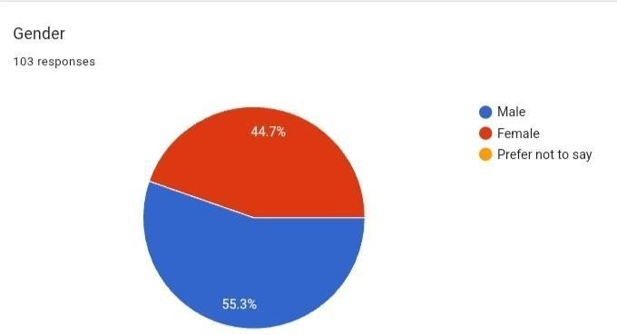

Out of 103 responses, 55.3% respondents were Male and 44m7% respondents were Female.

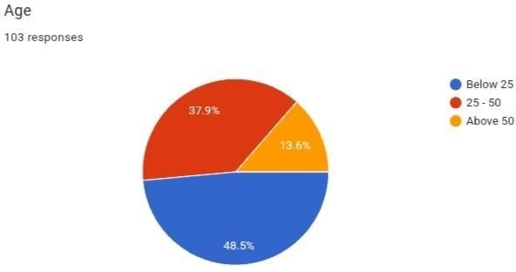

Out of 103 responses, 48.5% respondents were below the age of 25, 37.9% respondents were between the age of 25 – 50 and 13.6% respondents were above the age of 50.

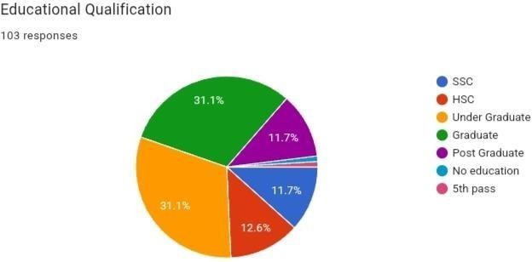

Out of 103 responses, 11.7% respondents have persued SSC, 12.6% respondents have persued HSC, 31.1% are Under-Graduates, 31.1% respondents are Post-Graduates, 11.7% respondents are Post-Graduated.

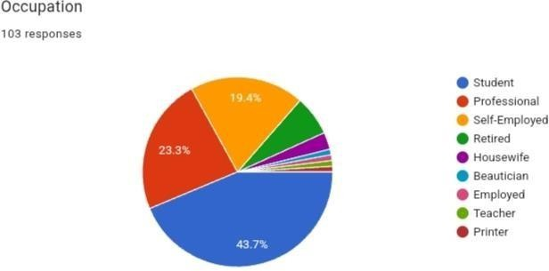
Out of 103 responses, 43.7 respondents are Students, 23.3% respondents are Professional and 19.4 respondents are Self-Employed.

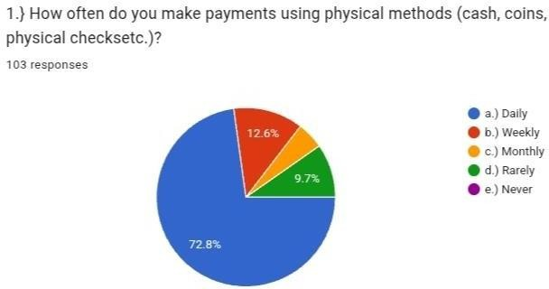

Out of 103 responses, 72.8% respondents use physical payment methods on daily basis.
12.6% respondents use it on weekly basis, 4.9% respondents use it on monthly basis and 9.7% respondents use it rarely.

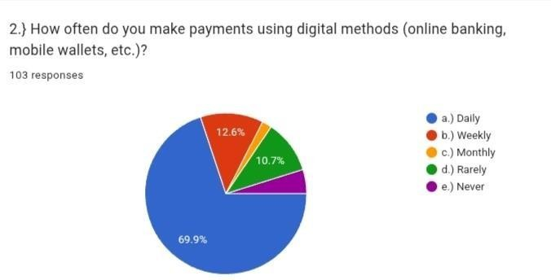

Out of 103 responses, 69.9% respondents use digitalized payment methods on daily basis, 12.6% respondents use it on weekly basis, 2.3% respondents use it monthly, 10.7% respondents use it rarely whereas; 4.5% respondents never use Digitalized payment methods.
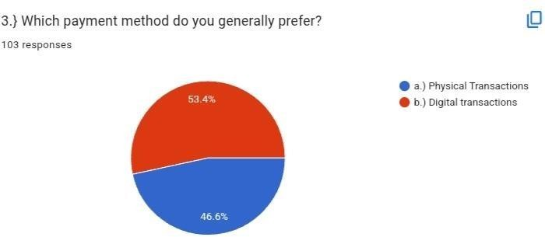
Out of 103 responses, 46.6% respondents generally prefer Physical Transactions whereas 46.6% respondents generally prefer Digital Transactions.

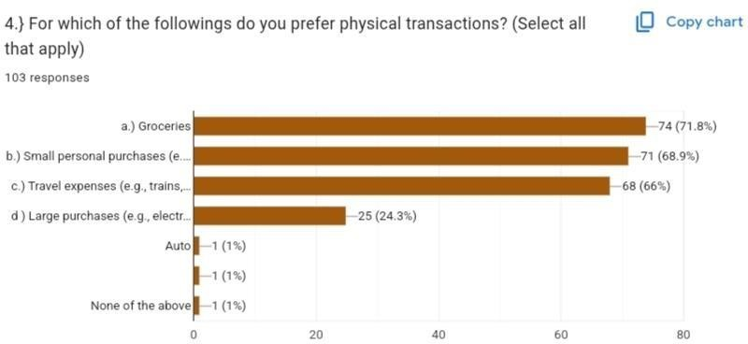
Out of 103 responses, most of the respondents make larger use of physical transactions for Groceries, and then also for small personal purchases, some of the respondents also use for travel expenses and then very less number of respondents use physical transactions for larger personal purchase.

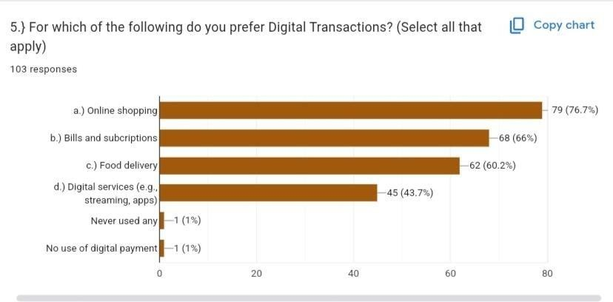
Out of 103 responses, Large number of respondents prefer Digitalized paymentethods for Online Shopping and for paying Bills and Subscriptions. Respondents also make use of Digitalized payment methods for processing payment of Food Delivery and for availing Digital services.
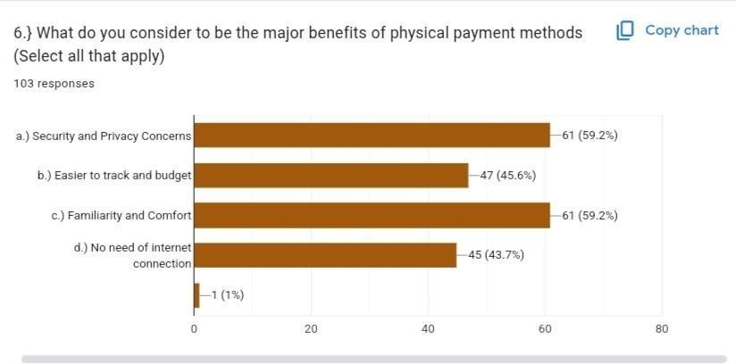
Out of 103 responses, Security and Privacy Concerns as well as Familiarity and Comfort are the major benefits of Physical methods considered by the Respondents. Respondents also feel that physical payment methods are easier to track and it doesn’t requires internet connection are good qualities of physical payments.
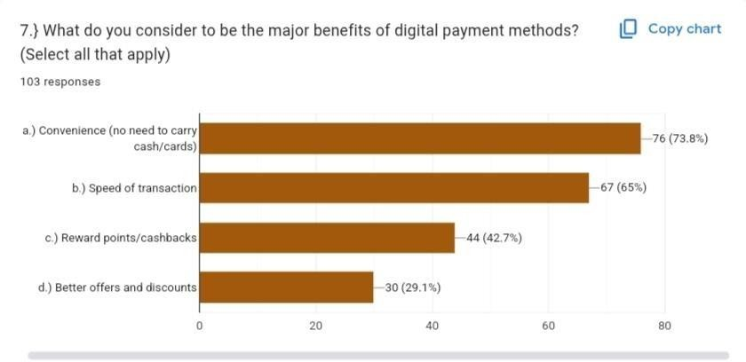
Out of 103 responses, Convenience is the utmost important benefit considered by the respondents, Speed of transactions and Reward points/cashbacks are the major benefits of digitalized payments considered by the respondents. The respondents are least interested in the better offers and discounts offered by the digitalized payment methods.

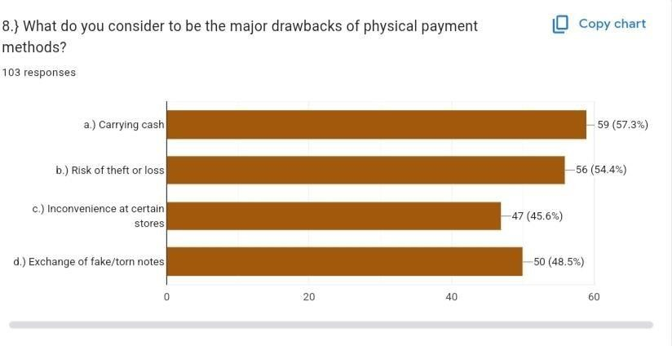
Out of 103 responses, As per the respondents, carrying cash and risk of theft or loss are the major drawbacks of the physical payments whereas Exchange of fale or torn notes and Inconvenience at certain stores are also observed to be the drawhacks kf pgysical payment methods.
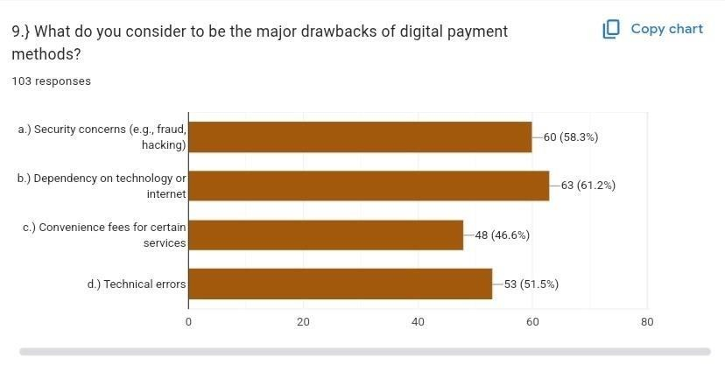
Out of 103 responses, Dependency on technology or internet is one of the major drawbacks of the Digitalized payment methods. As per the respondents, security concerns as well as technical errors lacks to choose digital payment method and convenience fees for certain services are also considered as the drawbacks of digital payment methods.

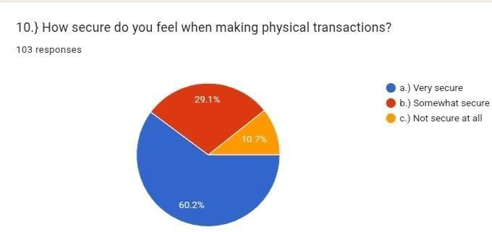
Out of 103 responses, 60.2% respondents feel physical transactions are very secure to use, whereas 29.1% respondents feel physical transactions are somewhat secure to use and 10.7% respondents feel that physical transactions are not secure at all.
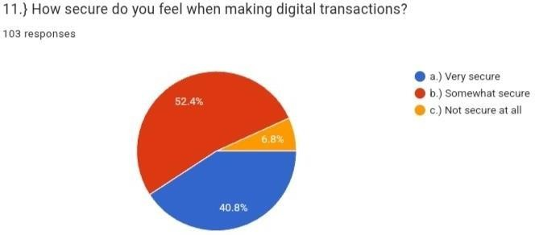

Out of 103 responses, 40.8% respondents feel digital transactions are very secure, whereas 52.4% respondents feel digital transactions are somewhat secure amd 6.8% respondents feel that digital transactions are not secure at all.
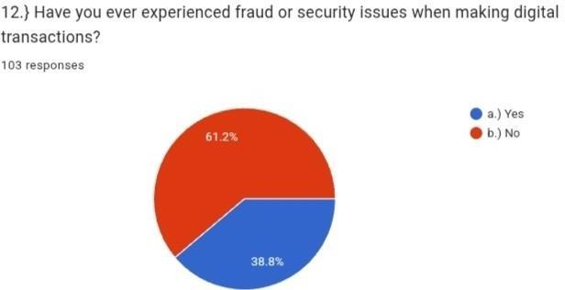

Out of 103 responses, 61.2% respondents have never experienced fraud or security issues but 38.8% respondents have experienced fraud and security issues when making digital transactions.

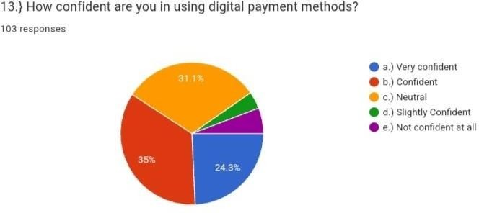
Out of 103 responses, 24.3% respondents are very confident, 35% respondents are confident, 31.1% respondents are neutral whereas 4.1% respondents are slightly confident and 5.3 % respondents are not confident at all.
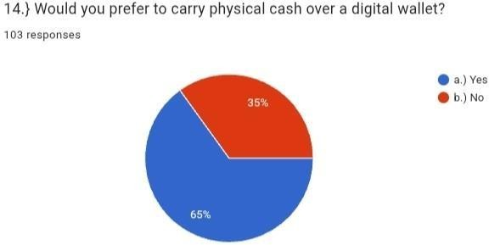

Out of 103 responses, 65% respondents prefer to carry cash over digital wallet whereas; 35% respondents do not prefer cash over digital wallet.

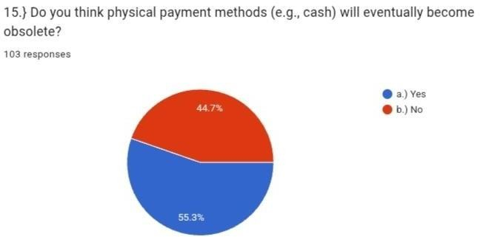
Out of 103 responses, 55.3% respondents think that physical payment methods (e.g., cash) will eventually become obsolete whereas; 44.7% respondents do not think that physical payment methods will not become obsolete.

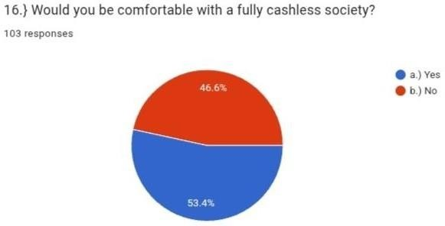
Out of 103 responses, 53.4% respondents are comfortable with a fully cashless society whereas; 46.6% respondents are not comfortable with fully cashless society.

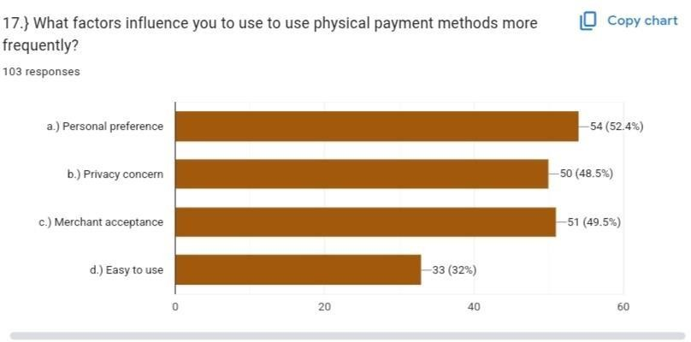
As per the respondents, the following is the bar graph representing the factors influencing them to use physical payment methods more frequently.

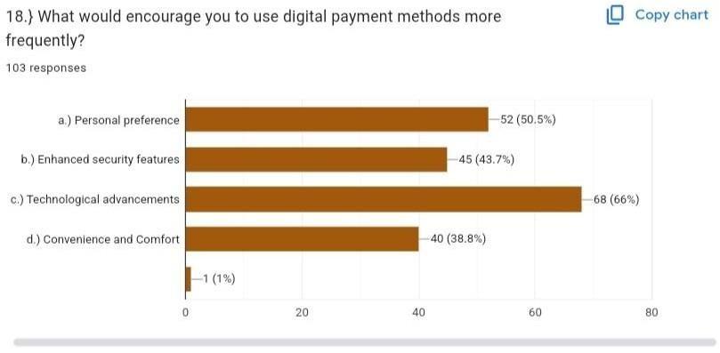
As per the respondents, the following is the bar graph representing the factors influencing them to use digital payment methods more frequently.

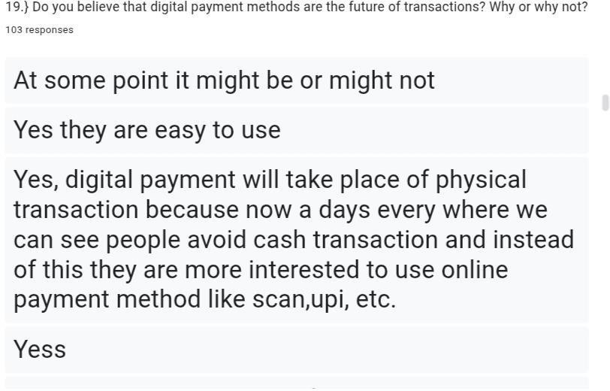

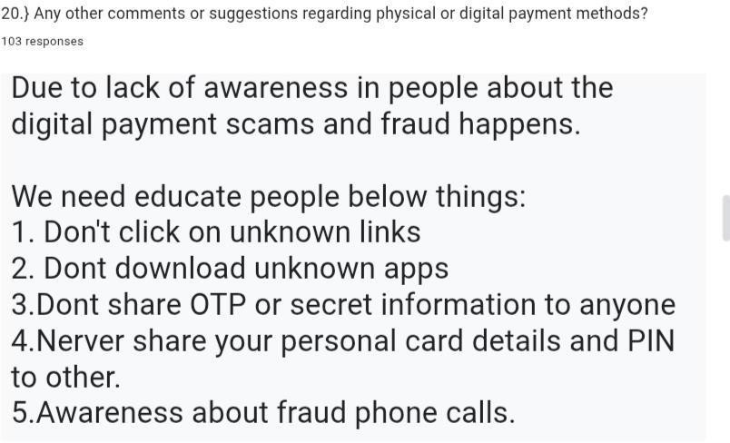

CHAPTER 9: FINDINGS

Findings on Sensitivity Towards Physical and Digitalized Transactions

- Perception of Security:
  - Physical Transactions: People often feel more secure using cash or physical payment methods as they can directly control the money and avoid the risks associated with digital fraud or hacking. Physical transactions are more "tangible," and users may feel that it’s harder for others to access their funds.
  - Digital Transactions: Many users express concerns about the security of digital transactions, particularly with the rise of online fraud, phishing, and data breaches. However, some users are reassured by the use of encryption, authentication protocols (e.g., two-factor authentication), and advanced fraud protection mechanisms.

- Privacy Concerns:
  - Physical Transactions: Cash payments are often preferred by those who value privacy, as they leave no digital footprint or trace of the transaction. There is a sense of anonymity in physical transactions, which appeals to individuals who are sensitive about sharing personal or financial data.
  - Digital Transactions: Digital transactions, especially those made through credit cards or mobile payments, involve the exchange of personal data that may be stored and tracked. Concerns around the collection and misuse of personal information are widespread, with some users wary about how companies handle their data.

- Convenience and Accessibility:
  - Physical Transactions: While cash is universally accepted, physical transactions can be less convenient, particularly in a fast-paced world where people may not always carry cash or need to find ATMs. Additionally, physical transactions require face-to-face interactions, which can be time- consuming.
  - Digital Transactions: Digital transactions offer greater convenience, as they can be made from anywhere with an internet connection. Mobile wallets, e-commerce platforms, and online banking services make it easy to transfer funds, purchase goods, and pay bills, especially in a time-sensitive environment. This convenience has driven an increase in digital payment adoption, particularly in developed countries.
- Generational Differences:
  - Physical Transactions: Older generations tend to have a greater sensitivity towards physical transactions, often because they have grown up using cash. They might feel more comfortable with face-to-face transactions or in-store payments.
  - Digital Transactions: Younger generations, on the other hand, are more inclined to use digital transactions, especially those who are more tech- savvy and accustomed to the convenience of smartphones, apps, and digital banking. They tend to embrace contactless payments, cryptocurrency, and e-commerce platforms with less hesitation.

- Transaction Speed:
  - Physical Transactions: Physical transactions can be slower, especially when dealing with cash or checks. People may need to wait for change, for clerks to process their payments, or for cash to be counted.
  - Digital Transactions: Digital transactions are generally faster, especially with the rise of contactless payments and mobile wallets. They enable immediate fund transfers and purchases, enhancing the overall user experience by reducing waiting times.

- Impact of Technology on Financial Inclusion:
  - Physical Transactions: Cash is an essential tool in regions with limited access to banking infrastructure. In such areas, physical transactions remain dominant as digital payments may not be widely accessible due to internet or smartphone penetration.
  - Digital Transactions: Digital payments are transformative in regions where banking infrastructure is limited. Mobile money services like PayPal, Venmo, and M-Pesa have allowed financial inclusion in underserved communities. However, people without access to smartphones or the internet are still excluded from this shift.

- Cost Sensitivity:
  - Physical Transactions: Cash transactions often don’t incur additional costs beyond the face value of the transaction, whereas using checks or cards might come with bank fees, particularly in international transactions or withdrawals from ATMs outside of a network.
  - Digital Transactions: While many digital payments are free (especially within the same network), certain digital transactions (e.g., wire transfers, foreign transactions, or credit card payments) can incur fees. However, digital currencies like cryptocurrency could eventually lower costs in international remittances.
CHAPTER 10 : CONCLUSION AND SUGGESTION OF THE
SENSITIVITY TOEARDS PHYSICAL AND DIGITALIZED
PAYMENT METHODS

Conclusions on Sensitivity Towards Physical and Digitalized Payment Systems
- Security Concerns: Users are generally more sensitive about the security of digitalized payment systems, fearing cyber threats such as fraud, hacking, or data breaches. While digital payments offer encryption and other security measures, there is still a significant portion of the population that remains cautious, particularly when it comes to sharing personal and financial information online. In contrast, physical transactions, particularly cash payments, are often viewed as more secure because they do not involve digital risks.
- Privacy Issues: Privacy remains a significant concern in digital transactions. Unlike physical transactions, which are often anonymous, digital payments inherently leave a trail of data that can be tracked, analyzed, or even misused by third parties. Many people are wary of the potential misuse of their personal information, especially as the reliance on data-driven platforms increases.
- Generational Divide: Younger generations are more likely to embrace digital payment methods, appreciating their convenience, speed, and ease of use. Older generations, however, remain more comfortable with physical payment systems, especially cash, due to their familiarity and the tangible sense of control they provide.
- Convenience and Accessibility: Digitalized payment systems offer unparalleled convenience, especially with the rise of mobile wallets, contactless payments, and online banking. However, this convenience comes at a cost: digital payment systems may be less accessible for individuals without smartphones or stable internet connections, creating barriers for certain segments of the population, particularly in rural or underdeveloped areas.
- Cultural and Societal Factors: Cultural influences also play a role in the sensitivity towards payment systems. In some societies, physical cash is culturally ingrained, and it remains the preferred method of transaction for many, especially for face-to-face payments. Conversely, in urbanized and more tech-savvy environments, digital payment systems are increasingly seen as the norm.
- Financial Inclusion and Economic Impact: Digital payments have shown promise in advancing financial inclusion, offering opportunities for individuals in underbanked regions to participate in the financial ecosystem. However, physical payments continue to dominate in many areas where banking infrastructure is limited or absent, highlighting the need for more widespread access to digital systems.
- Cost Sensitivity: While digital transactions are often faster and more convenient, they sometimes come with hidden costs such as transaction fees, exchange rate charges, or service fees for certain types of payments. In contrast, physical transactions, particularly cash, are often free of such charges. This cost sensitivity is particularly relevant for low-income individuals or those making international transactions

Suggestions for Improving Sensitivity Towards Both Payment Systems
- Enhancing Digital Payment Security:

    - Improvement: Continue to develop and implement more advanced security measures such as biometric authentication, end-to-end encryption, and fraud detection systems to address concerns regarding the safety of digital payments.
    - Suggestion: Increase transparency and educate consumers on the steps being taken to protect their data, which could help build trust in digital payment systems.

- Addressing Privacy Concerns:
    - Improvement: Implement stronger privacy protections in digital payment systems, such as limiting data collection to only necessary information and offering users more control over their data.
    - Suggestion: Offer opt-in privacy features, such as anonymous payment options or more discreet transaction methods, especially for sensitive transactions.

- Bridging the Generational Divide:
    - Improvement: Develop more intuitive and accessible digital payment systems for older generations, such as user-friendly interfaces, educational resources, and customer support to assist them in navigating digital payments.
    - Suggestion: Incentivize the use of digital payments through reward programs or low-fee services targeted at older users, making the transition easier.

- Increasing Accessibility and Inclusion:

    - Improvement: Ensure digital payment platforms are universally accessible by expanding internet and smartphone access in underserved regions. Governments and private entities could collaborate to improve infrastructure in rural or economically disadvantaged areas.
    - Suggestion: Create low-cost or no-cost digital payment options for people in low-income regions, ensuring that everyone has the opportunity to participate in the digital economy.
- Encouraging Hybrid Models:

  - Improvement: Promote hybrid payment systems that allow consumers to switch between physical and digital options seamlessly, depending on their preference, location, and transaction types.
  - Suggestion: Offer businesses incentives to support both payment methods, ensuring a wider range of payment options for consumers. For example, even in areas with high digital payment usage, ensure that cash payments remain a viable option for those who prefer them.

- Educating Consumers:
    - Improvement: Invest in widespread financial literacy programs that explain the benefits, risks, and best practices for both physical and digital payment systems.
    - Suggestion: Offer digital payment tutorials, emphasizing the advantages and safety features of digital systems, while also ensuring that consumers understand how to properly manage their physical money.

- Reducing Costs in Digital Transactions:

    - Improvement: Work with financial institutions and payment platforms to lower or eliminate fees for digital transactions, especially for low-income individuals or those making international payments.
    - Suggestion: Encourage the use of digital payments for small transactions through rewards or cashback schemes, helping consumers see the added value in switching from cash to digital systems.

- Maintaining the Role of Cash:

    - Improvement: Recognize that cash still plays a significant role in many communities and work to preserve access to physical payment methods even as digital systems proliferate.
    - Suggestion: Ensure that regulations are in place to maintain cash accessibility for those who rely on it, while promoting digital adoption where feasible.

CHAPTER 11: BIBLIOGRAPHY
https://scholar.google.com
https://www.researchgate.net
https://link.springer.com
https://dl.acm.org
https://www.allcommercejournal.com

https://journals.sagepub
CHAPTER 12: QUESTIONNIARE

Gender
Age
- Below 25
- 25-50
- Above 50
Education Qualification
- HSC
- SSC
- Under Graduate
- Graduate
- Post Graduate
- No education
- 5th pass
Occupation
- Student
- Professional
- Self – Employed
- Retired
- Housewife
- Beautician
- Employed
- Teacher
- Printer
- How often do you make payment using physical methods ( cash, coins, physical checks,
etc )
  - Daily
  - Weekly
  - Monthly
  - Rarely
  - Never
- How often do you make payments using digital methods ( online banking , mobile wallets ,etc.)
  - Daily
  - Weekly
  - Monthly
  - Rarely
  - Never
f)
- Which payment method do you generally prefer?
  - Physical transaction
  - Digital transactions

- For which of the following do you prefer physical transaction
  - Groceries
  - Small purchases
  - Travel expenses
  - Large purchases
  - Auto
  - None of the above

- For which of the following do you prefer digital transaction?
  - Online shopping
  - Bills and subscriptions
  - Food delivery
  - Digital services
- What do you consider to be the major of physical payment method?
  - Security and privacy concern
  - Easier to track and budget
  - Familiarity and comfort
  - No need of internet connection
- What do you consider to be the major benefits of digital payment methods?
  - Convenience
  - Speed of transaction
  - Reward of points and cashbacks
  - Better offers and discounts
- What do you consider to be major drawbacks of physical payment?
  - Carrying cash
  - Risk of theft or loss
  - Inconvenience at certain stores
  - exchange of fake / tone
- What do you consider to be major drawback of digital payment method?
  - Security concerns
  - Dependency on technology or internet
  - Convenience fees for certain services
  - Technical errors
- How secure do you feel when making physical transactions?
  - Very secure
  - Somewhat secure
  - Not at all secure
- How secure do you feel when making digital transactions?
- Very secure
- Some what secure
- Not at all secure
- Have you ever experience fraud or security issues when making digital transactions? a) Yes
b) No
- How confident are you in using digital payment methods?
  - Very confident
  - Confident
  - Neutral
  - Slightly confident
  - Not at all confident
- Would you prefer to carry physical cash over a digital wallet?
  - Yes
  - No
- Do you think physical payment methods will eventually become obsolete? a) Yes b) No
- Would you be comfortable with fully cashless society?
  - Yes
  - No
- What factors influence you to use physical payment methods more frequently?
  - Personal preference
  - Privacy concern
  - Merchant acceptace
  - Easy to use
- What factors influence you to use physical payment methods more frequently?
  - Personal preference
  - Enhanced security features
  - Technological advancement
  - Convenience and comfort

